Example: 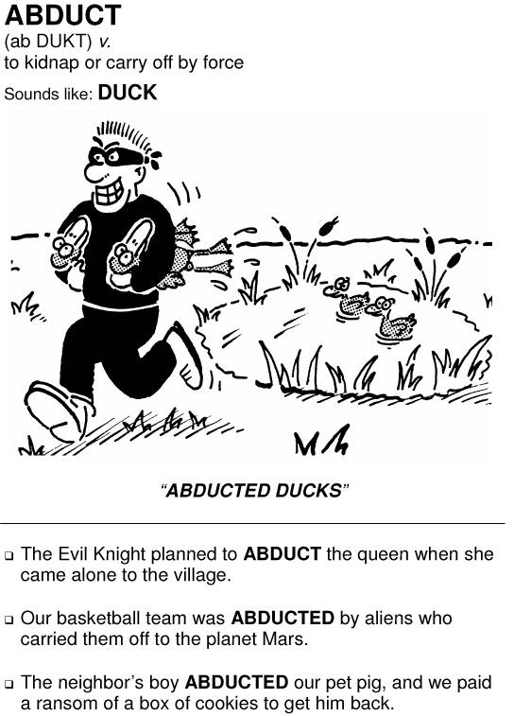

Word I choose: _________________________________________
ex: abduct

Meaning: ____________________________________________________________________________________
ex: kidnap or carry off by force

Words it sounds like: ________________________________________________________________________
ex: duck

I will draw ____________________________________________________________________________________
ex: a guy abducting ducks

My caption (include the word and the sounds like): ______________________________________
"abducted ducks"

You will also need to write two sentences using two different forms of the word. (Example: "abduct" and "abduction" are two different forms of the word)

Name:_______________________________________________ Period: ___________

Vocabulary Mnemonic: Unit 2

_____________________________________________
word

_______________________________________________________________________________________________
definition

________________________________________________
caption
illustration

Sentences:

1. ______________________________________________________________________________________________

_________________________________________________________________________________________________

2. ______________________________________________________________________________________________

_________________________________________________________________________________________________

