Teachers and Gamers Agree:

'Slave Tetris' Isn't How You Educate Kids About Slavery
Thanks to a social media backlash, a Danish company learned the hard way that there are better methods for teaching students about a painful chapter in history.

BY Liz Dwyer

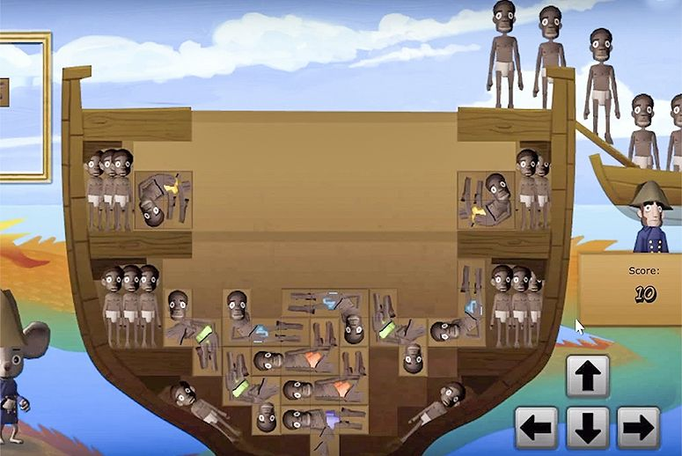
(Image: Courtesy YouTube)
SEP 1, 2015

Math facts, chemistry and biology, or coding—nowadays those are just a few of the subjects students can learn about through interactive online computer games. But educating 11- to 14-year-olds about the horrors of the slave trade through a video game that allows them to earn points by stacking bodies, Tetris style, in the hold of a slave ship?
That was one of the components of Playing History: Slave Trade 2, a game from Copenhagen, Denmark–based Serious Games Interactive. At least, it was until gamers and teachers alike took to Twitter over the weekend to let the company know that one of the most horrific, most brutal chapters in history shouldn’t be turned into educational fun.
“Travel back in time to the 18th century and witness the horrors of the trans-Atlantic slave trade firsthand. In this episode, you will be working as a young slave steward on a ship crossing the Atlantic,” reads the description of the game at the Steam store. “You are to serve the captain and be his eyes and ears—reporting any suspicious activities is your duty. But what do you do, when you realize that your own sister has been captured by the slave traders?”
Students could then earn points as the game took them through various scenarios of Africans being captured, held in cages, and suffering in chains on the slave ship. But folks were most outraged by the “Slave Tetris” section of the game, which let users stack captured people in the hold of the slave ship. The social media backlash against it was so severe, the company announced on Tuesday that that component of the game had been removed.
Although the game was first made available for computer download in September 2013, it was put on most Americans’ radars late last week. Serious Games Interactive advertised on Twitter that the title was discounted on Steam, a digital game store with more than 65 million users.
“I usually look through the new Steam releases and deals at least once a week and I saw this game. Just the title ‘Playing History’ seemed like it was a simple name for something that sounded like it would be for kids, but then the subtitle, the 'Slave Trade' part, piqued my interest," Terence Wiggins, a Virginia resident who runs two gaming podcasts and tweets as The Black Nerd, wrote in an email to TakePart.
Wiggins and other gaming aficionados condemned the game’s concept, particularly the slave-stacking part, on the social media platform. “ ‘Witness the horrors of slave trade firsthand’ by playing tetris w/ human bodies while a mouse watches,” tweeted user Harukio to Wiggins, sharing a screenshot of the Tetris-like component of the game.
Deray McKesson, an activist who has been prominent in the Black Lives Matter movement, retweeted a critique of the “Slave Tetris” section to his 223,000 followers. Dozens of educators also joined in, challenging the idea of teaching slavery through a game at all. “I didn't realize this was an interdisciplinary game. Look, slave math!” tweeted Frank Noschese, a high school physics teacher in New York.
Wiggins is surprised that the company decided to remove the "Slave Tetris" component of the game. “I've seen far too many developers stick to their guns when it comes to something controversial even when it benefits them not to,” he wrote. But just deleting the Tetris-like segment isn't enough, he added. “I do think they should get rid of the whole game. It's so bizarre and offensive and in all the weirdest ways," he wrote.
Rafranz Davis, a Fort Worth, Texas–based educational technology expert, also raised the call on Twitter for the game to be completely taken down from the Steam site, and asked educators to check if the game was being used in their schools.
“Gamifying slavery trivializes a serious time in history that shouldn't be fun. Kids should think, discuss, and be uncomfortable,” Davis wrote to TakePart. “They shouldn't be acquiring badges or accumulating points, which is how gamification works.”
This isn’t the first time an educational game about slavery has caused controversy. Last year Mission U.S.: Flight to Freedom, which takes students into the world of a 14-year-old slave girl, faced a similar backlash.
Teachers should absolutely educate students about slavery, wrote Davis, but they should use “primary source documents, critical discussion, and look at the economic impact on our country” instead. “Definitely not [through] role play or through gaming.”
Simon Egenfeldt-Nielsen, the CEO of Serious Games Interactive, initially seemed to make light of the controversy. “Contemplating what our next game will be.... something that can't possible hurt anybodiesfeelings... maybe just do a good old plan shooter,” he posted late Sunday night. Egenfeldt-Nielsen deleted his Twitter account on Tuesday.
“From a person who plays way too many video games, I'd rather not just see another shooter out on the market, especially coming from a person who made a game about the slave trade and tried to make it a cutesy adventure about being a young slave boy,” wrote Wiggins. “I think he needs to consult someone on his next project. Someone who's not going to look at a game called Playing History: Slave Trade 2 and think ‘Yeah, that seems like a smart idea for a game.’ ”

