Addy Walker, American Girl
The role of black dolls in American culture.
By Brit Bennett

1. In 1864, a nine-year-old slave girl was punished for daydreaming. Distracted by rumors that her brother and father would be sold, she failed to remove worms from the tobacco leaves she was picking. The overseer didn’t whip her. Instead, he pried her mouth open, stuffed a worm inside, and forced her to eat it. This girl is not real. Her name is Addy Walker; she is an American Girl doll, one of eight historical dolls produced by the Pleasant Company who arrive with dresses, accessories, and a series of books about their lives.

2. An American Girl store is designed like a little girl’s fantasyland, or what the Pleasant Company, owned by Mattel, imagines that to be. Pink glows from the walls; yellow shelves hold delicate dolls in display cases. Nurses tend to a hospital for defunct toys and a café hosts tea parties for girls and their dolls. The company has retired many of the historical American Girls from my childhood—the colonist Felicity, the frontierswoman Kirsten, and the World War II–era Molly, all among the original set of dolls, released in 1986—but Addy remains.

3. Against the store’s backdrop of pink tea parties, her story seems even more harrowing. Addy escapes to the north with her mother, forced to leave her baby sister behind because her cries might alert slave-catchers. In Philadelphia, Addy struggles to adjust and dreams of her family reuniting. They do, it turns out, find each other eventually—a near impossibility for an actual enslaved family—but at no small cost. Her brother loses an arm fighting in the Civil War. Her surrogate grandparents die on the plantation before she can say goodbye. Other American Girls struggle, but Addy’s story is distinctly more traumatic.

4. For seventeen years, Addy was the only black historical doll; she was the only nonwhite doll until 1998. If you were a white girl who wanted a historical doll who looked like you, you could imagine yourself in Samantha’s Victorian home or with Kirsten, weathering life on the prairie. If you were a black girl, you could only picture yourself as a runaway slave.

5. Since 2013, a Change.com petition has gathered nearly seventy signatures demanding that the Pleasant Company discontinue the Addy doll. “Slavery was a vile, cruel, inhumane, unjust holocaust of Black Americans,” the petition reads. “Why would this subject matter ever be considered entertaining?” The petition accuses the Pleasant Company of “diminish[ing] the cruelty of slavery and instead glorif[ying] it as some sort of adventurous fantasy.”

6. Dolls have never simply been toys, especially not throughout America’s racial history. In Righteous Propagation: African Americans and the Politics of Racial Destiny, Michele Mitchell writes about black reformers in the early twentieth century who argued that if beautiful white dolls reinforced white superiority and minstrel dolls reinforced black inferiority, then perhaps owning beautiful black dolls could teach children racial pride. Booker T. Washington wrote, in 1910, that black dolls “will have the effect of instilling in Negro girls and in Negro women a feeling of respect for their own race.” Marcus Garvey urged mothers to “give your children dolls that look like them to play with and cuddle so that they will learn as they grow older to love and care for their own children and not neglect them.”

7. A few decades later, dolls played a crucial role in toppling segregation. Dr. Mamie Clark and Dr. Kenneth Clark’s famous doll test presented children with two dolls, identical except for color and hair. The Clarks asked their subjects a series of questions: Which doll do you like to play with? Which doll is a nice color? When they asked the final question—Which doll looks like you?—many black children, who had until this point preferred the white doll, burst into tears. The Clarks testified as expert witnesses during Brown v. Board of Education, presenting their results as proof that segregation damages the self-esteem of black children.

8. The doll test has been replicated as recently as 2005, fifty years after desegregation, and the results remain the same. In one video, a black girl, asked which doll is prettier and smarter, points quickly to the white doll. She hesitates when asked which doll looks like her; her reluctance to touch the black doll breaks my heart.

9. In 2011, the Pleasant Company launched their second black historical doll, Cécile, a girl growing up in 1850s New Orleans. She has a white best friend and dreams of finding a gown for the Children’s Ball at Mardi Gras. Many black parents were relieved when Cécile was introduced. Shelley Walcott, a Milwaukee reporter, wrote that although she “believes learning about the history of slavery in America is critical and should in no way be hidden from our children,” she had also wished that the Pleasant Company would release another black doll, one that “celebrated a more positive time in African American history.”
“As a parent,” she writes, I find Cécile’s story a lot more appropriate for playtime than plantation scenes and a bullwhip-cracking slave master … Much of African American history is painful. And I’m glad to see the folks at American Girl have introduced a new doll that can allow children’s fantasies to be … less intense.

10. But Cécile was discontinued in 2014, along with the only historical Asian American doll, Ivy Ling. Cécile is light-skinned with long, beautiful ringlets. She dreams of pretty dresses.

11. In “A Talk to Teachers,” James Baldwin describes the inevitability of young black children discovering “the shape of [their] oppression”:
As adults, we are easily fooled because we are so anxious to be fooled. But children are very different. Children, not yet aware that it is dangerous to look too deeply at anything, look at everything, look at each other, and draw their own conclusions. They don’t have the vocabulary to express what they see … but a black child, looking at the world around him, though he cannot know quite what to make of it … is aware that there is some terrible weight on his parents’ shoulders which menaces him.

12. Perhaps playing with dolls like Addy and reading books about her life provides children with the language to confront that terrible, menacing weight of racism. Perhaps it is better to have language, even when language hurts.

13. Still, I envy the privilege of not knowing. In 2013, Laura Murphy, a Virginia mother, made news when she pushed for the school district to allow students to opt out of reading Toni Morrison’s Beloved. The book, she claimed, was “too intense for teenage readers”; reading it had given her seventeen-year-old son nightmares.

14. Well, good—Beloved should give your child nightmares. Why should her son be allowed to opt out of a horrifying history just because it unsettles him? Her son admitted that the book was “hard for [him] to handle,” so he just gave up on it. Murphy later argued that she was not trying to ban the book; instead, she wanted a choice, as a parent, to decide whether her children could be exposed to “disturbing” content. She expects the ability to protect her child’s innocence. But, as Bernstein argues, childhood innocence has always been raced white. White children feel pain. Black children are barely children.

15. A recent study in the Journal of Personality and Social Psychology found that subjects perceived black boys to be an average of four-and-a-half-years older than their actual age. In some cases, a black child was perceived as an adult when he was only thirteen. “Children in most societies are considered to be in a distinct group with characteristics such as innocence and the need for protection,” the study reads. But black boys are seen as responsible for their actions “at an age when white boys still benefit from the assumption that children are essentially innocent.”

16. Is it any surprise then, that Tamir Rice, a twelve-year-old black boy playing with a toy gun in a park, was shot by police before the cruiser even came to a full stop? The 9-1-1 caller had warned that the gun was “probably fake,” Rice “probably a juvenile.” And yet an officer shot the boy in seconds. Moments before, surveillance video shows Rice stomping on snowballs, like any child might do. When the 9-1-1 caller spotted him, he was sitting on a playground swing.

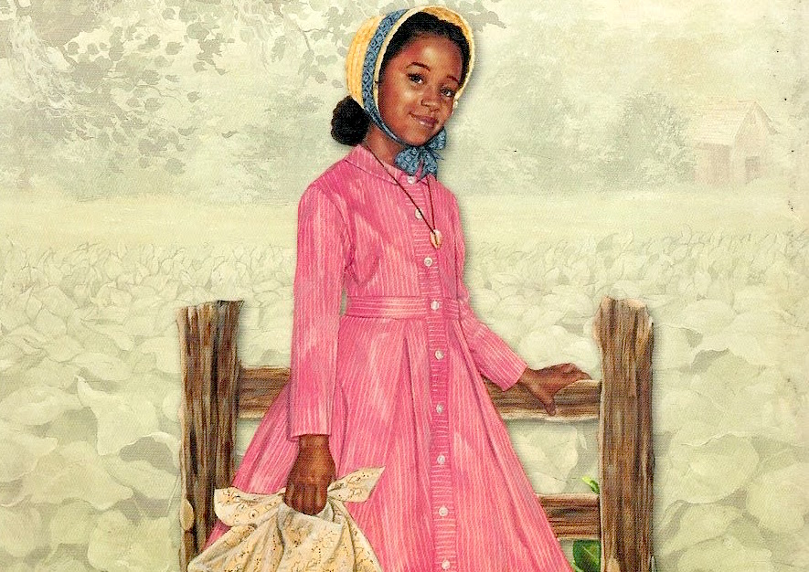
FROM THE COVER OF MEET ADDY.

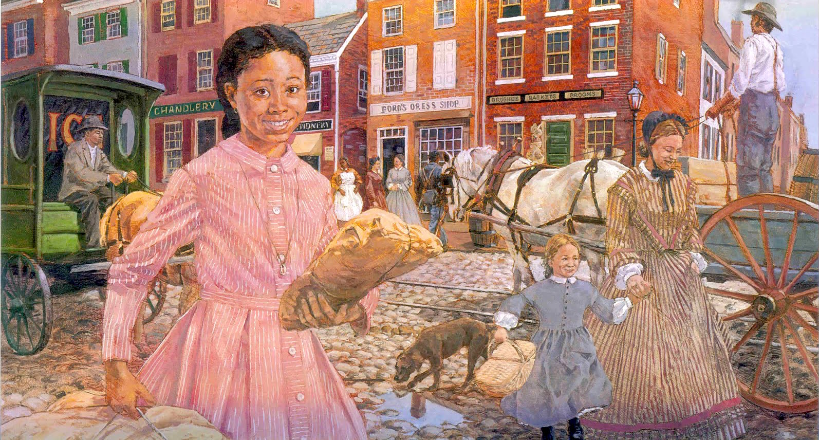
FROM ADDY’S WORLD

