PODCAST
RECORDING & EDITING DIRECTIONS

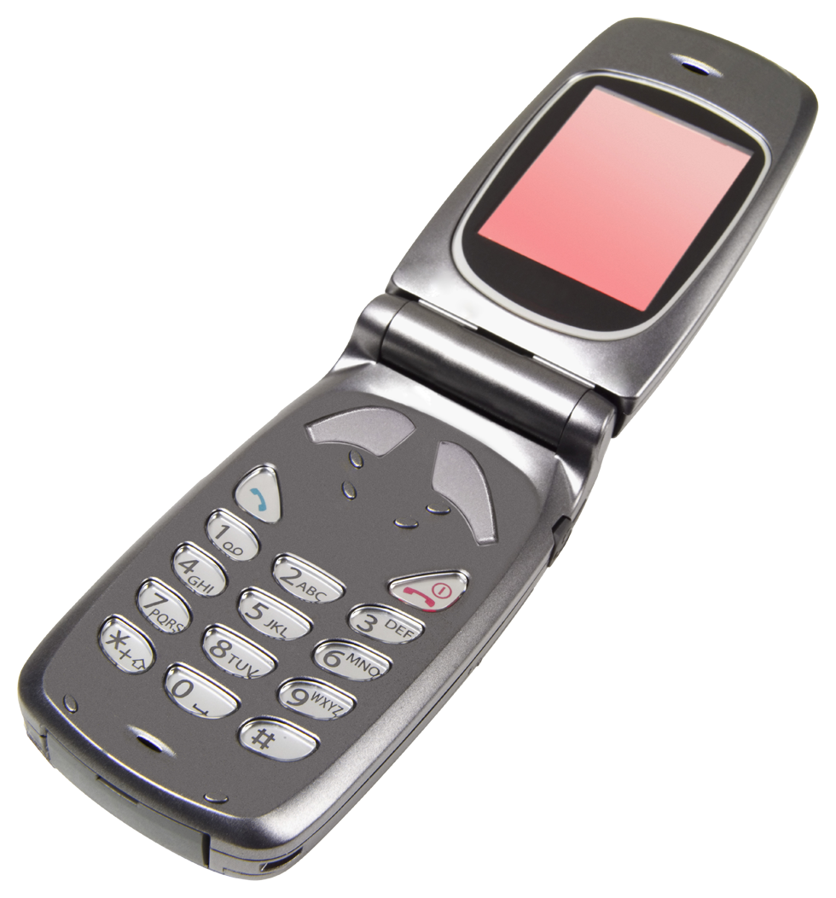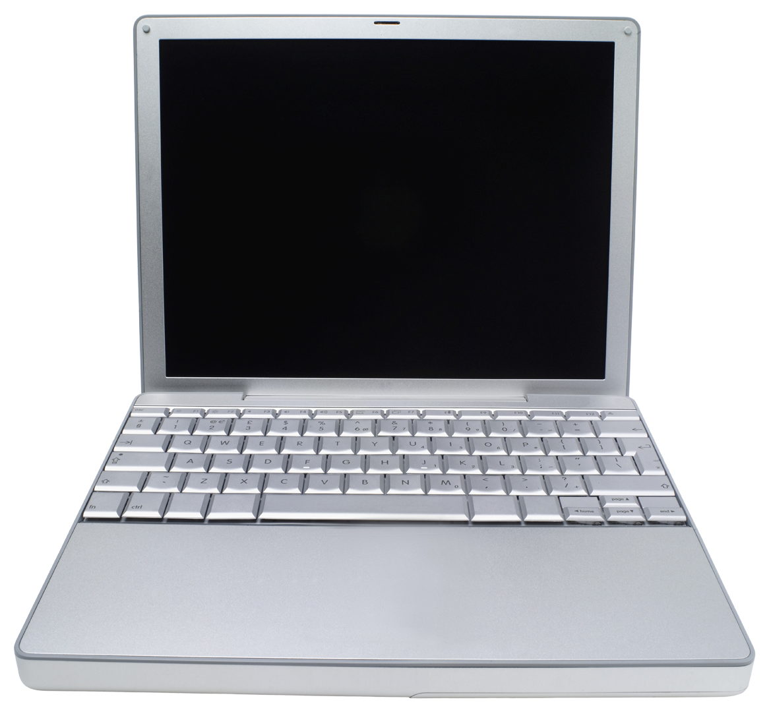

REMINDERS:
Don't talk over each other. Don't interrupt each other.
If you mess up, you don't have to stop the recording, just go back and say it again.

1. Record your podcast on VoiceMemo or whatever recording software you have. You may choose to record yourself reading your poem separately to edit in later. Just make sure you read the poem in the same room you did your discussion. You might want to have multiple people record the discussion just in case.

2. Export the recording(s) to your Google Drive.

3. In Google Drive, open the recording and download it to your computer.

4. In Chrome, go to www.soundtrap.com. You will need to start a new account by logging in with your DPS Google Account.

5. Click "Import File" and select your podcast discussion.

6. Name your file with the title of your podcast and your first names. Example: "Too Sharp to Bear with Holly and Alexa"

7. Share your file with your group members' emails so everyone has editing abilities. Click on the blue circle with the people to share.

8. Unclick the purple scope-looking circle in the upper-right hand corner. That is "snap to beat" which will give you less precision in your editing. It's good for music, but not for voice.

GETTING AROUND SOUNDTRAP:
- The playhead is the arrow at the top of the bars.
- If you push the spacebar it will play.
- To split a section (to edit it out), click Ctrl+e with your playhead where you want it to split.
- To delete a section, simply click it and press Delete on the keyboard.
- Did you make a mistake? CTRL + Z will undo!
- To show a closer view of the minutes, click the zoom in or zoom out.
- Click the pink Save button regularly.

Keyboard Shortcuts for Soundtrap
GENERAL |  |  |  |  | EDITOR
Play / Pause |  | Space |  |  | Move region |  | Shift + arrow keys.
Record | Ctrl + Space |  |  |  | Toggle selection |  | Shift + click
Rewind | Arrow left |  |  |  | Delete region |  | Delete
Fast forward | Arrow right |  |  |  | Zoom to selection |  | Ctrl/Cmd + click and drag
Back to top / restart recording | Enter |  |  |  | Zoom in / out |  | Ctrl/Cmd + arrow left / right. For mouse: Ctrl/Cmd + mouse wheel
Undo | Ctrl/Cmd + Z |  |  |  | Scroll up / down |  | Mouse wheel
Redo | Ctrl/Cmd + Shift + Z |  |  |  | Scroll left / right |  | Shift + mouse wheel
Cut | Ctrl/Cmd + E |  |  |  | Split region |  | Ctrl/Cmd + e
Copy | Ctrl/Cmd + C
Paste | Ctrl/Cmd + V
Fine knob / slider adjustment | Shift + mouse drag

Want to make your own background music?

You can use GarageBand if you have it on your phone and know how to use it. I would also recommend:
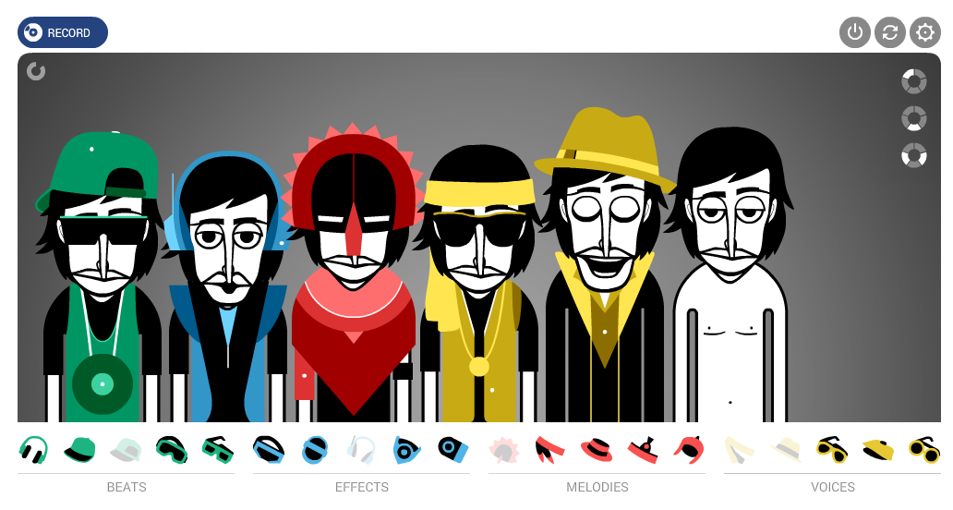  Incredibox.com  1. Click V1, V2, V3, or V4 to start.  2. Drag a sound onto the figure that appears. Keep adding sounds until you like the mix.  3. Click RECORD at the top and get at least 1 minute of sound. If you want to give one part a solo, click on the headphones on that figure. To mute a part, click on the audio icon on that figure.  4. Export the file to save on your computer.  5. Upload the file from your computer to your Google Drive.  6. Upload the file into Soundtrap. | 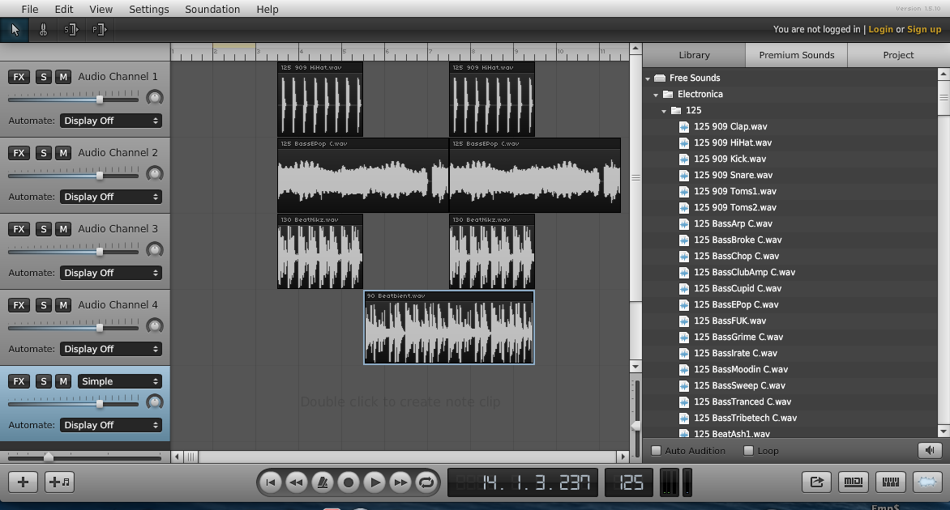  Soundation.com  1. Click "Launch the Studio." You will need to create a Free Account using your DPS Google Account.  2. On the "Free Sounds" files on the right, open up the folders and drag over sounds to the left until you like what you have. Make sure you have enough music for your intro and closing.  3. Done? Click the Export button in the lower right.  4. Save the file to your computer and then immediately upload it to Google Drive.  6. Upload the file into Soundtrap

