English I &
Honors English I

http://garvoille.wordpress.com

@Ms_Garvoille

alexa.garvoille@dpsnc.net

(919) 560-3926 x23406
11:15-12 or 2:30-3:15




Ms. Garvoille [GAR-voyl] Ms. Prather [PRAY-ther]
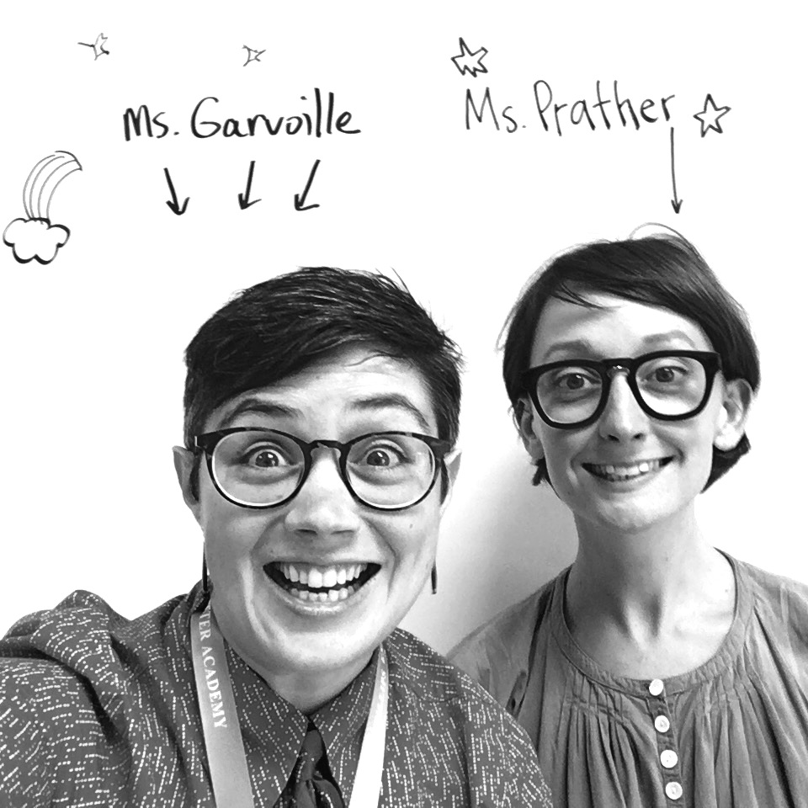
2016 – 2017 Duke MAT '17 paige.prather@duke.edu

Welcome to English I!
A writing-intensive, creative, project-based class with Ms. Garvoille and Ms. Prather.

STATS
Garvoille Prather
Teaching Year 8 Teaching Year 1
DSA Year 6 DPS Sub Year 2
Arts High School Grad Doc film & photo teacher
Sponsor of QSA, Lit Mag Lived in TX, NY, OR, MS
Wisconsin-born Austin-born
Yale '07 UT '07
Duke MAT '09 Ole Miss '14
Duke MAT '17

Fill out our contact info form:
http://bit.ly/2bRJIWs

Materials
1” Binder separated into 5 sections:
Information, Literature, Writing, Grammar, Vocab
Folder with pockets for homework
Composition or spiral notebook
Timetracker or assignment book

Classroom Wish List
Tissues!
Pens, pencils, highlighters, markers, colors
Dry-erase markers
Lysol wipes
Construction paper and art supplies
donorschoose.org/garvoille

Though all books are available through the school, the English department recommends that students, especially those enrolled in Honors English I, obtain personal copies that they can write in. Below is a list of novel-length texts we will likely be reading:

To Kill a Mockingbird or Go Set a Watchman, by Harper Lee. (December)
If you have already read To Kill a Mockingbird in middle school, you will read Go Set a Watchman.
Romeo and Juliet, by William Shakespeare. (April)
Students enrolled in Standard English may purchase a copy with a side-by-side modern language summary. Students enrolled in Honors English should purchase a copy with only the original Shakespeare plus footnotes. I recommend the Barnes & Noble or Yale edition.
The Odyssey, by Homer. Penguin Books. Translated by Robert Fagles. (May)

Key Information
- Website: There is a class website: http://garvoille.wordpress.com. A class agenda, homework downloads and announcements are posted daily. This is an excellent resource for students and parents.
- Text Message Reminders: Sign up for Remind text messages/emails: text @agarvo to 81010. Or send an email to agarvo@mail.remind.com.
- Project-based: You must complete all major projects, which count for most of your grade. If you don’t pass English I, it will be very difficult to graduate from DSA in four years.
- Independent Reading: We have found high schoolers report having less time and interest to read for pleasure than they did in middle school. High school English teachers are also asking students to read more complex class texts in high school, leading to negative feelings about reading. Independent reading will be part of our daily class schedule.
- Honors vs. Standard: Students in Honors English with a grade of 70 or below on the first report card will be automatically switched to regular English for the rest of the year. If you are enrolled in an Honors class, you can earn an extra quality point on your GPA.
- Plagiarism: Copying (from a friend or the internet) will result in redoing an assignment and possibly a referral. It's better to turn it in late than copy it! Most
- Tutoring: I am available before and after school by appointment. I stay after school almost every day until 5:30. Though some days I will be running club meetings, you can always find me. I can send you home with a pass so your parents know you were with me.
- Power Lunch: If you are failing English at the progress report or the quarter, you will attend Power Lunch every day until the next progress report or report card.
Course Overview
English I will prepare you for a rigorous high school experience. This class involves daily writing in all sorts of genres as well as challenging but rewarding readings. Throughout the year, we will study various genres, or types of literature, including memoir, novels, plays, documentary films, paintings, and even music videos. We study grammar through sentence patterns to help us become better writers, vocabulary via Greek and Latin word roots, and literary devices as we read and write literature. Here’s a rough sketch of our four quarters, subject to change based on student needs:

1st | Creative Non-Fiction. Text: Book club memoir of choice, selected short memoirs. Project: Personal memoir.
1st | Poetry. Text: Assorted poems. Project: Poetry Out Loud recitation, Poetry Podcast.
2nd | Critical Media Literacy. Text: Assorted essays, book club novel of choice. Project: Product review.
3rd | Novel. Text: To Kill a Mockingbird or Go Set a Watchman. Project: Collaborative essay.
3rd | Speech-Writing. Texts: various speeches. Project: Activist Speech and artwork.  Play. Text: Fences and Death of a Salesman. Project: Analysis and written monologue.
4th | Shakespeare. Text: Romeo and Juliet. Project: Critical essay and performed adaptation.
4th | Epic. Text: The Odyssey. Project: Seminar.

Grading
Weighted Breakdown:

Practice 20% | Mastery 80%
Homework  Classwork  Rough drafts  Reading checks | Projects  (1-3 per quarter)  Vocab Tests  Revisions
Rationale: Grades show your mastery of a certain topic. Mastery is only accomplished after many trial runs and feedback. You will prove that mastery through projects, essays, and tests. Grades on those big evaluations make up the majority of your letter grade. Homework is where you practice, make mistakes, and learn from your teacher’s comments, so the grade will not count as much because it’s only testing how much you understand partway through your learning process. But just because it doesn’t count for as large a percentage, doesn’t mean it’s not important. Like an athlete who must practice to do well at the big game, you must do the homework to succeed on the projects. All English I teachers use this scale.

Honors vs. Regular English I
Each student has the choice to complete the course at the Honors level, which adds extra weight to your GPA. In my class, Honors students will have more complex reading, additional components to projects, and more competitive grading. For example, a paper that earns an A in regular English will earn a B in Honors English. Likewise, quizzes and tests for Honors and regular English I are often different. Additionally, those enrolled in Honors must complete one Honors project at any point in the school year. This will count as a project grade. Additional Honors Projects may be completed for extra credit.
If enrolled in Honors, the grade on your first quarter report card must be a C- (70) or above; if below, you will be automatically switched to regular English, where you will be more successful. Only a parent petition at a conference can stop this process. In addition, any student who has not completed the summer assignment will be automatically enrolled in regular English. If enrolled in regular English and you would like to switch up to Honors, you may only do so in the first quarter, and your grade must be an A (90).

Thank you!
We're looking forward to an awesome year! Please let me know if you have any concerns throughout the year, or if you'd like to help out in some way. Welcome to high school!

