Raisin in the Sun Reading Guide
Use this sheet to help you organize information about characters. As you read, fill out each character’s want (what is their motivation, what do they want?), obstacle (what stands in their way of getting what they want?), and flaw (what personality trait holds them back from getting what they want?).

Setting
Time | Place
Characters

Draw lines showing the connections between characters.

Love
Power
Conflict

wants:

obstacle:

Lena Younger
(Mama)

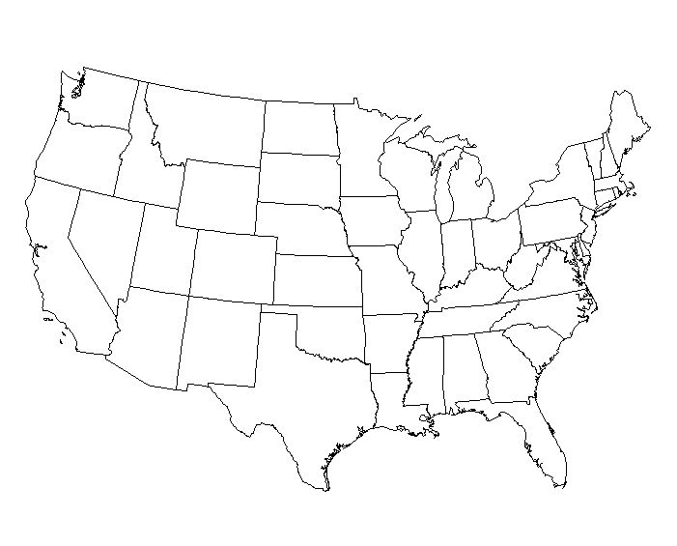

Walter Younger
(Big Walter)
Joseph Asagai

wants:

obstacle:

wants:

obstacle:

flaw:

Beneatha Younger
(Bennie)

wants:

obstacle:

flaw:

Walter Lee Younger

Lennie Small

wants:

obstacle:

flaw:

Ruth Younger

Claude

George Murchison
wants:

obstacle:

Chicago, IL

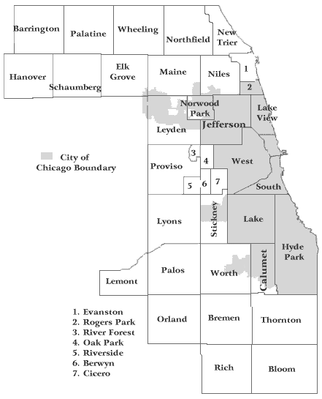

Karl Lindner

wants:

obstacle:

wants:

obstacle:

Travis Younger

Bobo

Mrs. Johnson

