Name _______________________________________________________ Period ____________
ART ANALYSIS: BAR AT THE FOLIES-BERGERES AND PICTURE FOR WOMEN
You will work with a partner for this activity, but both of you must complete a separate answer sheet.
You will share a computer with your seat partner for this art analysis activity. I selected these images because they deal with themes addressed in “The Love Song of J. Alfred Prufrock”: isolation and others’ expectations.
- Navigate your browser to garvoille.wordpress.com and click on the two pictures to open them in new tabs.
- Complete all the questions for Bar at the Folies-Bergeres. Then, you will complete the same questions for image 2, Picture for Women.
IMAGE 1: BAR AT THE FOLIES-BERGERES by Eduard Manet (painting, 1882)
1. Zoom in and scroll around, examining the painting. For at least three whole minutes, write down everything you see in this box. Take your time. Include colors, objects, expressions, shapes, and details.
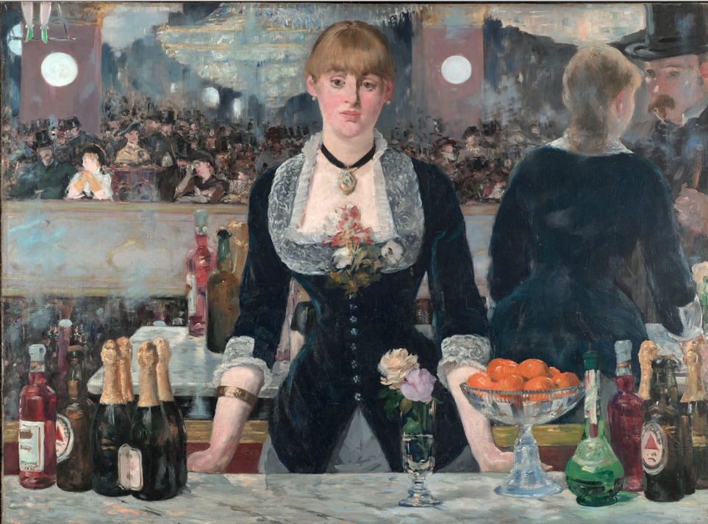
- Woman wearing jewelry
- chandelier

Include a minimum 20 words or phrases for full credit.

2. Now, examine how contrast appears in this painting.
Which specific visual details suggest power, bonding, confidence, or trying to be yourself? You may draw from what you wrote down in the box above. Explain how three different details communicate three positive feelings or ideas in the painting. | Which specific visual details suggest powerlessness, isolation, self doubt, or trying to please others? You may draw from what you wrote down in the box above. Explain how three different details communicate three negative feelings or ideas in the painting.
Ex: The lady is pretty and well groomed. She is wearing lace and jewelry. She shows care for her appearance. This indicates power. | Ex: Her hunched shoulders reveal self-doubt. She has this jewelry, why is she working as a barmaid? Who gave it to her? (Trying to please others/powerlessness)
- power  - bonding  - confidence  - trying to be yourself | - powerlessness  - isolation  - self-doubt  - trying to please others
- power  - bonding  - confidence  - trying to be yourself | - powerlessness  - isolation  - self-doubt  - trying to please others
- power  - bonding  - confidence  - trying to be yourself | - powerlessness  - isolation  - self-doubt  - trying to please others
3. How does the artist show that sometimes other people’s expectations who or what we should be can affect the way we act, think, and present ourselves to the world?
__________________________________________________________________________________________
__________________________________________________________________________________________
__________________________________________________________________________________________
__________________________________________________________________________________________
4. Make a connection between this image and “The Love Song of J. Alfred Prufrock.” Explain the similarity, difference, or connection you make. Use a piece of evidence from both the poem (a quote and stanza number) and the painting (a visual detail) to prove your point.
__________________________________________________________________________________________
__________________________________________________________________________________________
__________________________________________________________________________________________
__________________________________________________________________________________________
__________________________________________________________________________________________
__________________________________________________________________________________________
__________________________________________________________________________________________

IMAGE 2: PICTURE FOR WOMEN by Jeff Wall (photograph, 1979)
1. Zoom in and scroll around, examining the photograph. For at least three whole minutes, write down everything you see in this box. Take your time. Include colors, objects, expressions, shapes, and details.
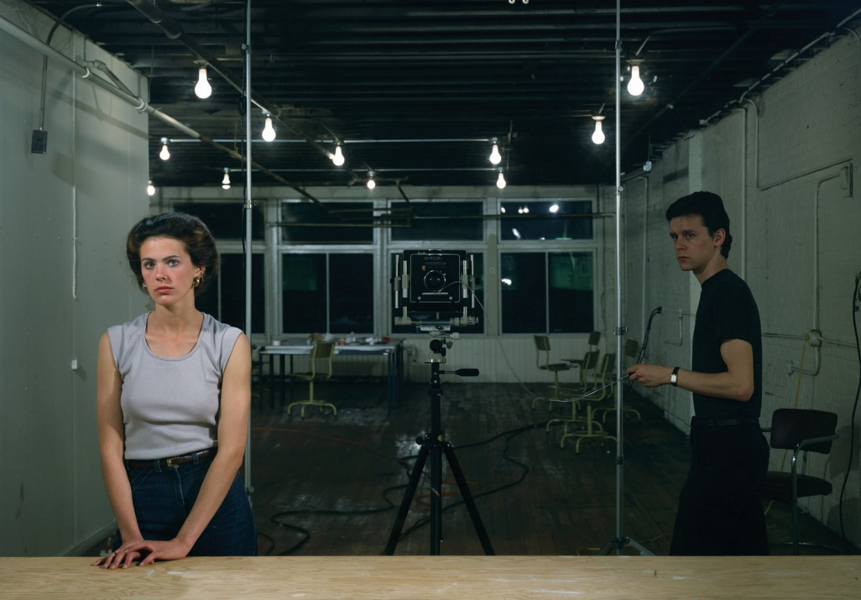
- Camera in center
- Woman in front leaning on bar

Include a minimum 20 words or phrases for full credit.

2. Now, examine how contrast appears in this photograph.
Which specific visual details suggest power, togetherness, confidence, or trying to be yourself? You may draw from what you wrote down in the box above. Explain how three different details communicate three positive feelings or ideas in the photograph. | Which specific visual details suggest powerlessness, isolation, self doubt, or trying to please others? You may draw from what you wrote down in the box above. Explain how three different details communicate three negative feelings or ideas in the photograph.
Ex: The man and woman have the same facial expression. (Togetherness) | Ex: The woman is standing far away from the man. (Loneliness/isolation)
- power  - bonding  - confidence  - trying to be yourself | - powerlessness  - isolation  - self-doubt  - trying to please others
- power  - bonding  - confidence  - trying to be yourself | - powerlessness  - isolation  - self-doubt  - trying to please others
- power  - bonding  - confidence  - trying to be yourself | - powerlessness  - isolation  - self-doubt  - trying to please others

3. How does the artist show that sometimes other people’s expectations of who or what we should be can impact the way we act, think, and present ourselves to the world?
__________________________________________________________________________________________
__________________________________________________________________________________________
__________________________________________________________________________________________
__________________________________________________________________________________________

4. Make a connection to between this image and Bar at the Folies-Bergeres. How are they similar?
__________________________________________________________________________________________
__________________________________________________________________________________________
__________________________________________________________________________________________
__________________________________________________________________________________________

5. Make a connection between this photograph and “The Love Song of J. Alfred Prufrock.” Explain the similarity, difference, or connection you make. Use a piece of evidence from both the poem (a quote and stanza number) and the photograph (a visual detail) to prove your point.
__________________________________________________________________________________________
__________________________________________________________________________________________
__________________________________________________________________________________________
__________________________________________________________________________________________
__________________________________________________________________________________________
__________________________________________________________________________________________
__________________________________________________________________________________________

