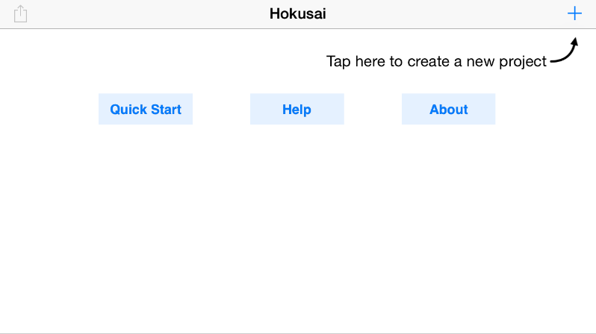 | Hokusai Tutorial  1) On your iPhone visit the App Store and search for Hokusai Audio Editor. The app should look like this:    It should also be free, so tap Download as soon as you find it.  After downloading, tap on the app and you will see the screen pictured to the left. At the top right of the screen is a ‘+’ sign. Tap it to start a new project.
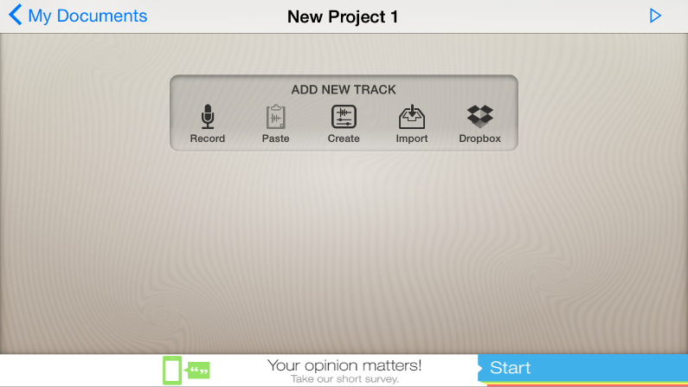 | 2) Before you begin recording your voice, notice the icons on the track panel; Record, Paste, Create, Import, and Dropbox.  For now, we are just going to use the Record button. After pressing it, you will be taken to a different screen.
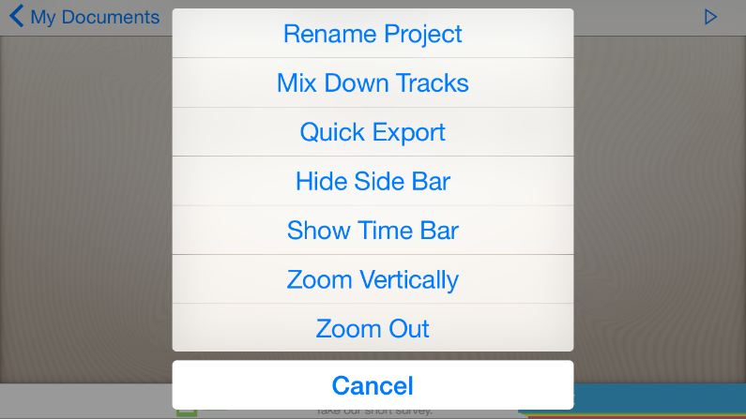 | 3) If you tap on the top of the screen, where it says “New Project 1”, you will be presented with these options pictured to the left.  You can Rename your project, mix tracks, export, and so on. For now, we are only going to use the Rename Project option, if you choose to do so.  Click Cancel to bring up your project again.
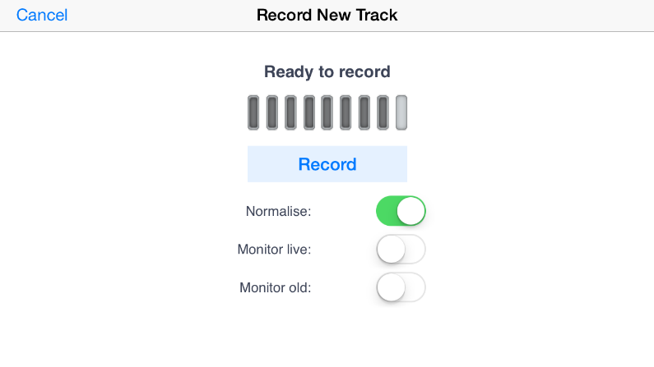 | 4) If you tap on the Record option in the “Add New Track” panel (pictured in box 3) you will be taken to the screen here on the left.  A line of grey bars will flicker indicating the volume of the sound coming through the mic. Tap Record to begin recording your voice, music, or sound effect.  Click Stop to end your recording.
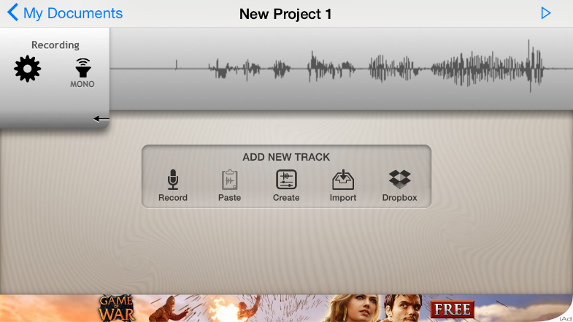 | 5) After recording your sound, you will see it listed as one of the tracks on the screen with your project.  IMPORTANT: Tracks must be highlighted BLUE in order to edit it. To highlight any track in blue, just press down on it with one fingers and expand the blue slider that appears to cover the whole track.
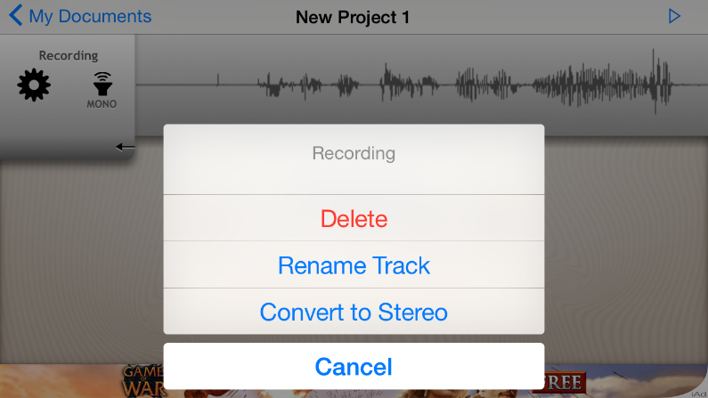 | 6) Tapping on the black gear under Recording, on the left of the screen, will bring up the following options. You can either Delete the track, which cannot be reversed, Rename the track, or Convert it to stereo.  For now, we are only going to use the Delete and Rename option.  To record multiple tracks, just tap the Record option under the “Add New Track” panel.
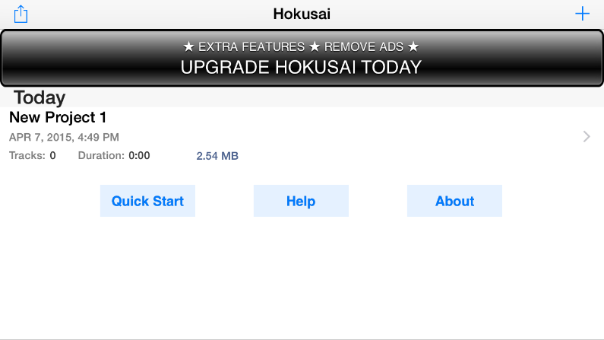 | 7) Tapping on the “My Documents” option located at the top left (pictured in number 6) will bring you to this screen. Here you can add new projects, as well as delete unused ones.
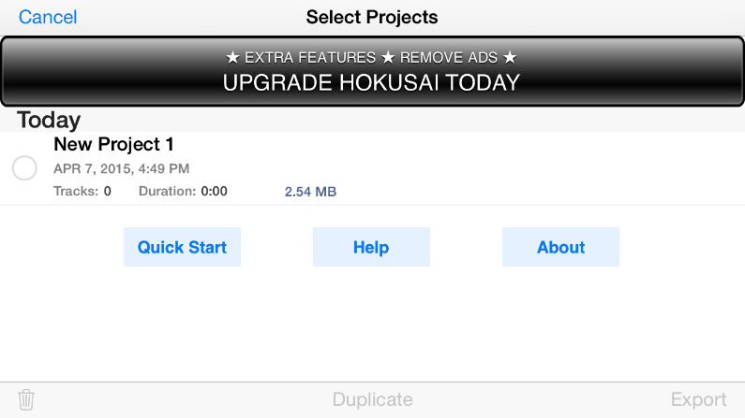 | 8) If you press the button on the top left  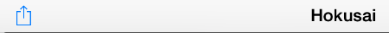  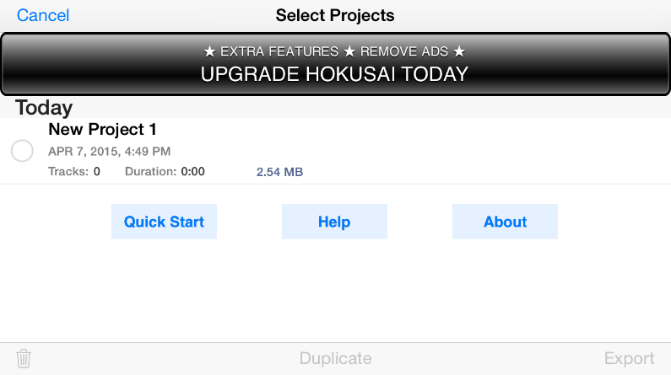  A small, grey circle will appear next to your project, as well as this panel of options on the bottom of the screen:  The Garbage Can is to delete your file, while Duplicate will make another copy, and Export will export your project. For now we are only going to use the first two options.
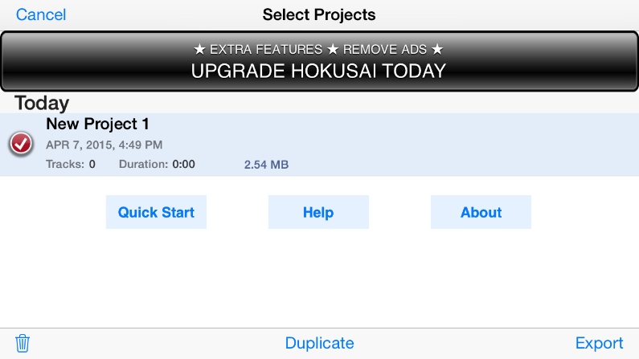 | 9) Tapping on the grey circle will create a Red Checkmark, giving you the option to delete or duplicate your project.  IMPORTANT:  Deleting is irreversible! So be careful with the files you want to delete.

