Garage Band Tutorial 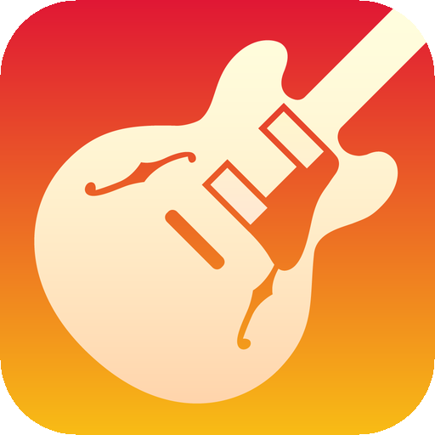
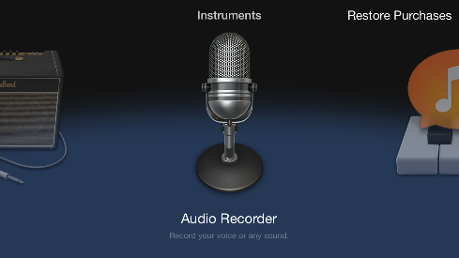

Open your App Store application on your iPhone. Look for the Garageband icon and download it. After opening Garageband, swipe left until you see Audio Recorder then select it.
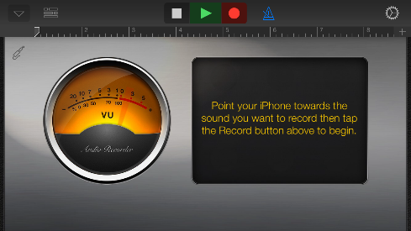

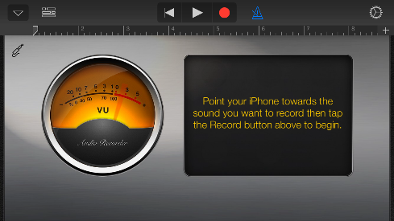
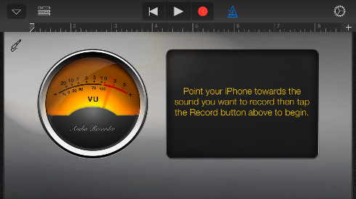
This screen will appear once you select Audio Recorder. At the top you will find .These buttons indicate: go back to the beginning, play, and record. The blue triangle is a metronome. It will sound off once recording begins. The yellow circle indicates whether or not your voice can be heard. The red line will flick to the right if your voice is loud enough for the recorder.

To begin recording, press the Red Circle. The metronome (blue triangle) will begin ticking. Tap it to stop the metronome. A green play button and a red record button indicate that your voice is being recorded. The Folder Button to the right of the upside down triangle (upper left-hand corner) will take you to a different screen.

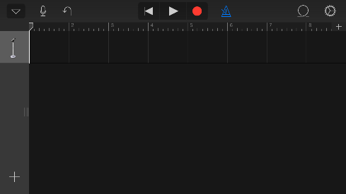
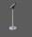
Pressing the Folder Button will bring you to this screen where you will see how many Audio Tracks you have recorded. This microphone icon represents one track.
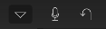
Tapping this microphone will take you back to the audio recorder.

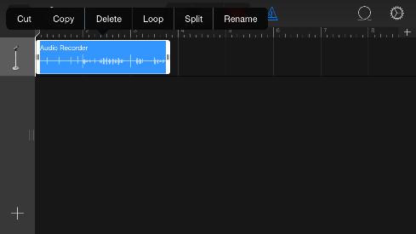
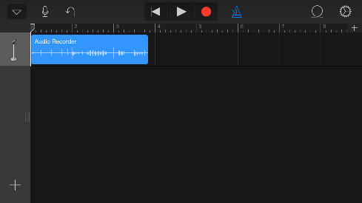
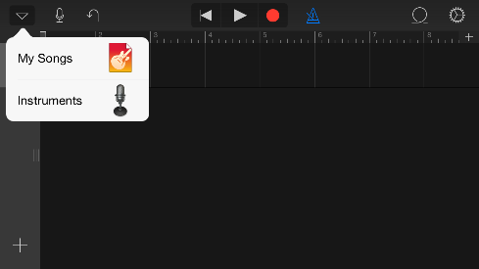

The upside down triangle on the upper left-hand corner will open a small menu that says My Songs and Instruments. The My Songs option will lead you to a screen that shows your project. The Instruments option will lead you back to the screen where you selected Audio Recorder.

After recording audio, it will appear as a blue rectangle in the audio track. You can edit it by tapping on the track itself. Drag your fingers apart to stretch the recording, or pinch them together to shorten it.

By clicking directly on the blue rectangle, the following options will appear above it; Cut, Copy, Delete, Loop, Split, and Rename. Each of these options will edit the clip as you feel appropriate. Use this audio recorder to record your interviews, your dramatic readings, and the sound effects and music you will incorporate into your podcast.

