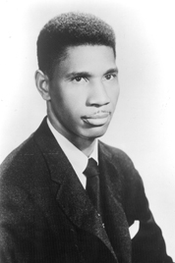 | 1. MEDGAR EVERS (Born 1925 in Decatur, Miss., slain by gunman June 12, 1963, in Jackson, Miss.) Evers became active in the National Association for the Advancement of Colored People (NAACP) after seeing the dismal living conditions of blacks while working as an insurance salesman in rural Mississippi in the early 1950s. He became a recruiter for the NAACP and was named the group's field secretary for Mississippi in 1954. In the late 1950s and early 1960s Evers led campaigns to register black voters and organized boycotts of firms that practiced racial discrimination. He was killed by Ku Klux Klan member Byron de La Beckwith. Evers' murder became a major rallying point in the civil rights movement, prompting greater and more strident grass-roots activism. Beckwith was tried for his murder twice in 1964 but all-white juries deadlocked in their decision and he escaped conviction. In 1994, Beckwith was convicted and sentenced to life in prison.
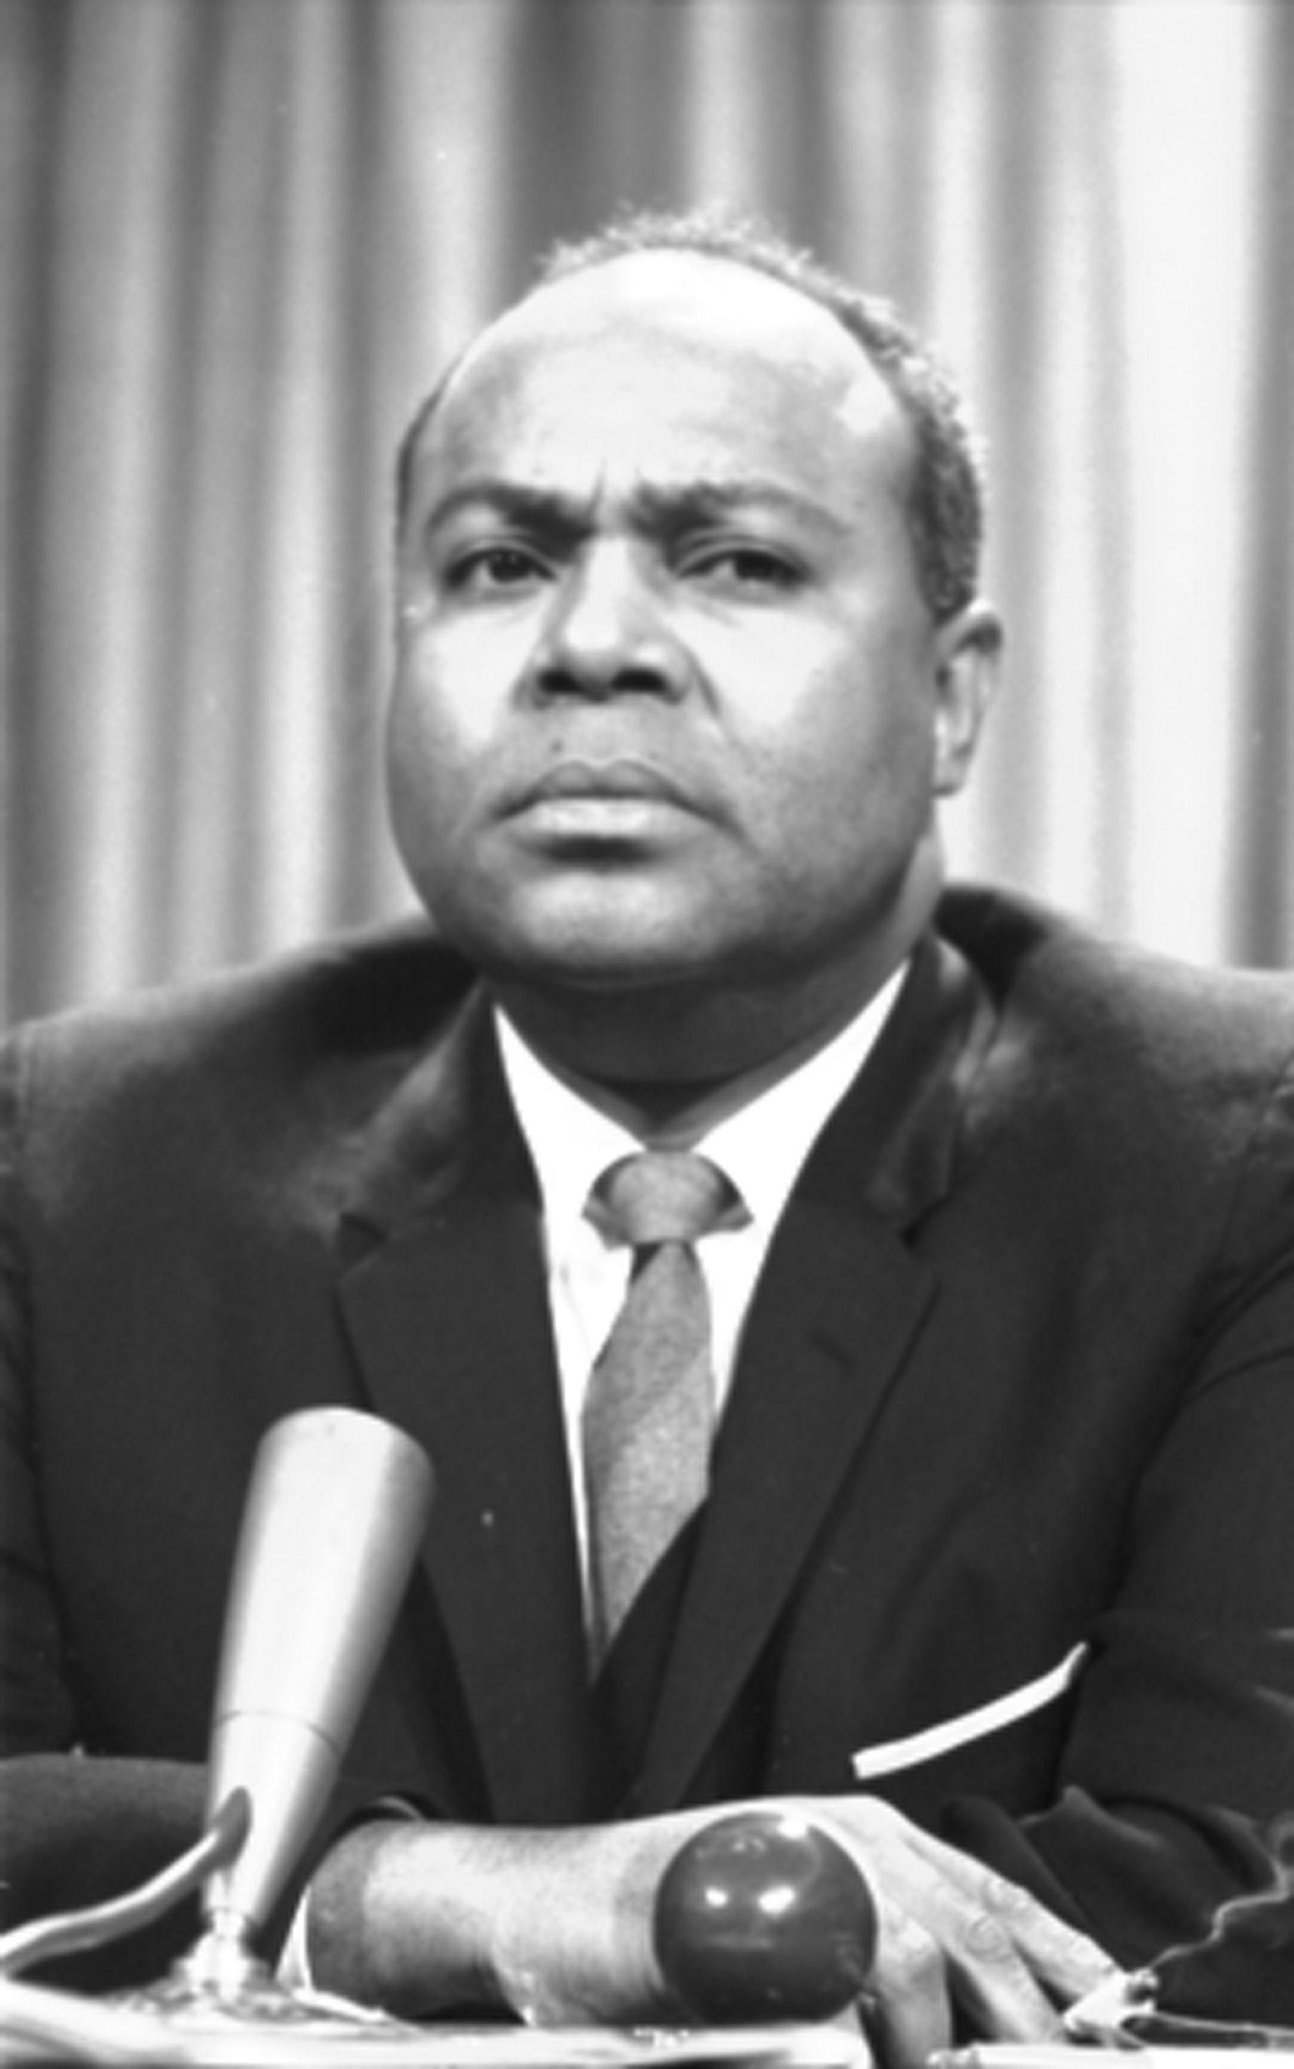 | 2. JAMES FARMER — (Born Jan. 12, 1920, in Marshall, Texas; died July 9, 1999, in Fredericksburg, Va.) Farmer worked closely with Martin Luther King, and had been a prominent civil rights activist since co-founding the Congress of Racial Equality (CORE), a civil rights organization that was the first in the United States to use nonviolent tactics to protest racial discrimination. In the early 1960s he was a chief organizer of the "Freedom Rides" in which white volunteers traveled on interstate buses with blacks. The black Freedom Riders used restaurants, restrooms, and waiting areas reserved for whites, while the whites used colored facilities. The Freedom Riders, who frequently confronted violent mobs, challenged the federal government to enforce anti-segregation legislation that had recently been passed. He ran unsuccessfully for Congress in New York in 1968, and served in the Nixon administration as an assistant secretary in the Department of Health, Education and Welfare. Farmer wrote about the civil rights struggle in his autobiography, Lay Bare the Heart (Texas Christian University Press, 1998). President Clinton awarded Farmer the Presidential Medal of Freedom in 1998.
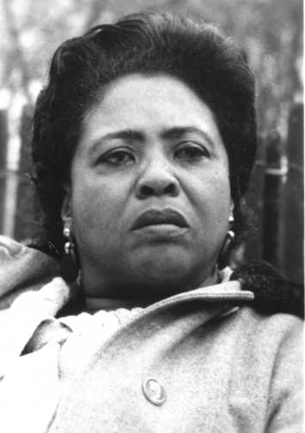 | 3. FANNIE LOU HAMER — (Born Oct. 6, 1917, in Montgomery County, Miss.; died March 15, 1977.) The daughter of Mississippi sharecroppers, Hamer was born into a life of poverty. Although she received little formal education, she became one of the most dynamic speakers of the civil rights movement. She is widely known for the phrase "I am sick and tired of being sick and tired." Hamer became active in the movement when members of the Student Nonviolent Coordinating Committee (SNCC) and the Southern Christian Leadership Conference came to Mississippi. She worked on voter registration drives in the South. She was among several workers stopped by officials in Winona, Miss., on June 9, 1963. She and other workers were jailed and beaten. SNCC lawyers bailed her and the others out and filed suit against the Winona police. All the whites who were charged were found not guilty. She continued to work on grass-roots anti-poverty, civil rights, and women's rights projects into the 1970s.
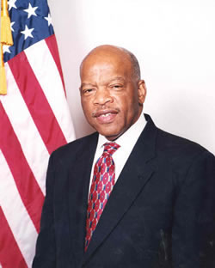 | 4. JOHN LEWIS — (Born Feb. 21, 1940, near Troy, Ala.) He grew up on his family's farm and attended segregated public schools in Pike County, Ala. In 1961, he volunteered with the Freedom Riders, challenging segregation at interstate bus terminals across the South. Lewis was among the many Riders who were beaten severely by segregationist mobs. From 1963 to 1966, Lewis chaired SNCC, which he helped form. Lewis, just 23 years old at the time, was a planner and keynote speaker at the Aug. 28, 1963, "March on Washington." In 1964, he coordinated SNCC efforts to organize voter registration drives and community action programs during the "Mississippi Freedom Summer." On March 7, 1965, Lewis and fellow activist Hosea Willams led more than 600 marchers across the Edmund Pettus Bridge in Selma, Ala. State troopers attacked the marchers in a confrontation that became known as "Bloody Sunday." That march and a subsequent one between Selma and Montgomery, Ala., led to the Voting Rights Act of 1965. Elected to Congress in November 1986, Lewis represents Georgia's 5th Congressional District and is currently serving his ninth term.
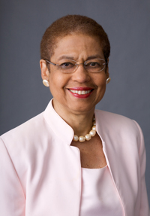 | 5. ELEANOR HOLMES NORTON — (Born June 13, 1937, in Washington, D.C.) Became active in civil rights movement while attending Antioch College in Ohio. While a student a Yale Law School, she became active in the SNCC's work in Mississippi in 1963. She was one of the chief organizers of the 1963 March on Washington. Norton was appointed to chair the Equal Employment Opportunity Commission by President Jimmy Carter in 1977, becoming the first woman to hold the post. She is now in her seventh term as the congresswoman for the District of Columbia.
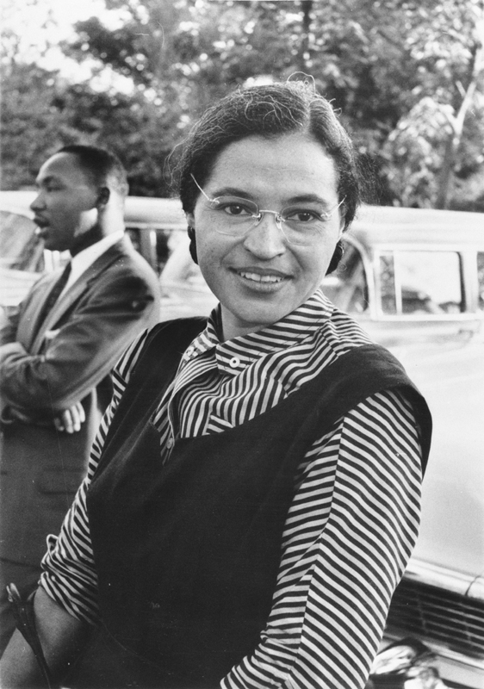 | 6. ROSA PARKS — (Born Feb. 4, 1913, in Tuskegee, Ala.) Many historians mark the beginning of the modern civil rights movement to Dec. 1, 1955 — the day Parks refused to give up her seat to a white passenger on a Montgomery, Ala., bus. She was arrested and fined for violating a city ordinance. Park's action led to the formation of the Montgomery Improvement Association, headed by Martin Luther King Jr. The association called for a boycott of the city-owned bus company. The boycott lasted 382 days and gave new prominence to Parks, King, and the civil rights cause. The Supreme Court in 1956 struck down the Montgomery ordinance under which Parks had been fined, and outlawed racial segregation on public transportation.
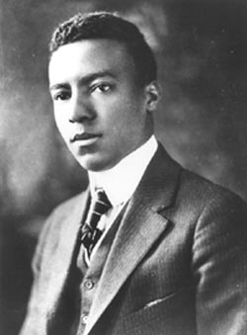 | 7. A. PHILIP RANDOLPH — (Born April 15, 1889, in Crescent City, Fla.; died May 16, 1979, in New York City) Concerned over the treatment of black workers on railroads, Randolph organized the Brotherhood of Sleeping Car Porters in 1925, the first union of predominantly black workers granted a charter by the American Federation of Labor. Randolph played a key role in persuading President Franklin D. Roosevelt to establish the Fair Employment Practices Committee in 1941. He wanted to stage a civil rights march on Washington that year, but Roosevelt was concerned about potential violence. Randolph organized the League for Nonviolent Civil Disobedience Against Military Segregation. The league's efforts prompted President Harry S. Truman in 1948 to issue an executive order banning segregation in the armed forces. Randolph was one of King's closest advisers and was one of the main organizers of the 1963 March on Washington.
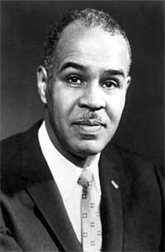 | 8. ROY WILKINS — (Born Aug. 30, 1901, in St. Louis; died Sept. 8, 1981, in New York City) The grandson of a Mississippi slave, Wilkins was a tireless activist in the cause of civil rights, leading the National Association for the Advancement of Colored People (NAACP) from 1931 to 1977. He helped lead the legal battle against school segregation that resulted in the 1954 Supreme Court decision outlawing "separate but equal" public schools. He is credited by many with being the driving force behind the passage of the landmark 1964 Civil Rights Act.
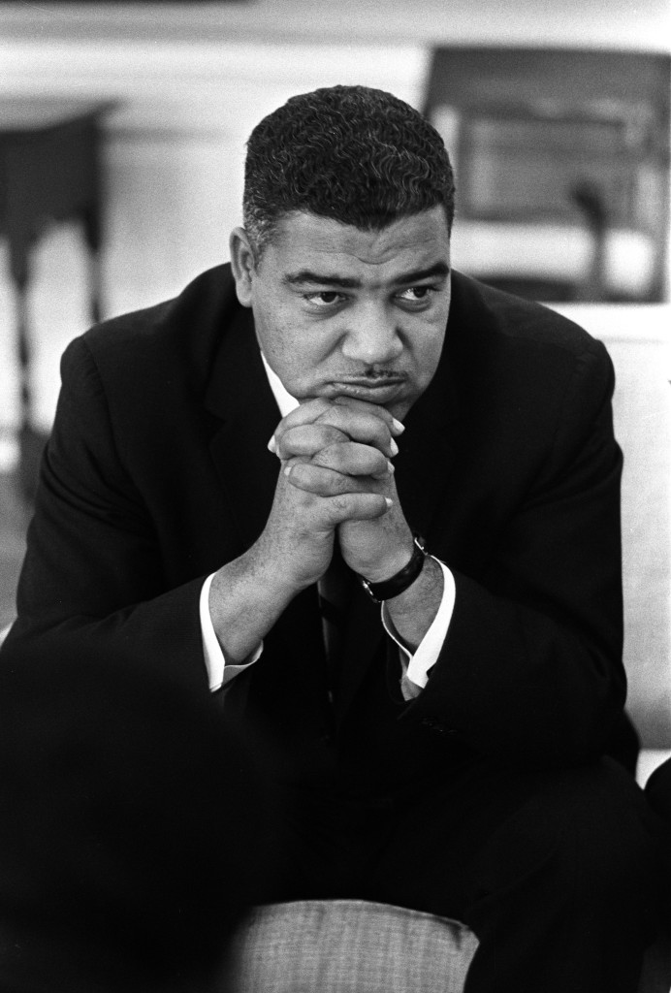 | 9. WHITNEY YOUNG — (Born July 31, 1921, in Lincoln Ridge, Ky.; died March 11, 1971, in Lagos, Nigeria) Young became active in the civil rights movement while a graduate student in social work at the University of Minnesota. He joined the National Urban League, an organization devoted to protecting the rights of minorities. He was dean of the Atlanta University School of Social Work from 1954 to 1961, and became active with King and other Southern civil rights leaders during his tenure there. From 1961 until his death he was executive director of the Urban League. As an adviser to President Lyndon B. Johnson, Young had a major influence on federal antipoverty policies in the 1960s.
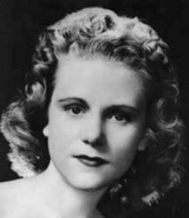 | 10. Viola Fauver Gregg Liuzzo (April 11, 1925 – March 25, 1965) was a Unitarian Universalist civil rights activist from Michigan. In March 1965 Liuzzo, then a housewife and mother of 5 with a history of local activism, heeded the call of Martin Luther King Jr and traveled from Detroit, Michigan to Selma, Alabama in the wake of the Bloody Sunday attempt at marching across the Edmund Pettus Bridge. Liuzzo participated in the successful Selma to Montgomery marches and helped with coordination and logistics. Driving back from a trip shuttling fellow activists to the Montgomery airport, she was shot by members of the Ku Klux Klan. She was 39 years old.  One of the four Klansmen in the car from which the shots were fired was Federal Bureau of Investigation (FBI) informant Gary Rowe.[1][2] Rowe testified against the shooters and was moved and given an assumed name by the FBI.[3] The FBI later leaked what were purported to be salacious details about Liuzzo which were never proved or substantiated in any way.
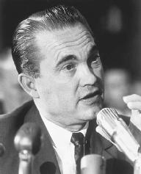 | 11. George Corley Wallace, Jr. (August 25, 1919 – September 13, 1998) was an American politician and the 45th Governor of Alabama, having served two nonconsecutive terms and two consecutive terms as aDemocrat: 1963–1967, 1971–1979 and 1983–1987. Wallace has the third longest gubernatorial tenure in post-Constitutional U.S. history at 5,848 days.^{[1]} After four runs for U.S. President (three as a Democrat and one on the American Independent Party ticket), he earned the title "the most influential loser" in 20th century U.S. politics, according to biographers Dan T. Carter^{[2]} and Stephan Lesher.^{[3]}  A 1972 assassination attempt left Wallace paralyzed, and he used a wheelchair for the remainder of his life. He is remembered for his Southern populist and^{[4]} segregationist attitudes during the mid-20th century period of the African-American civil rights movement and activism, which gained passage of federal civil rights legislation in the mid-1960s to enforce constitutional rights for all citizens. He eventually renounced segregationism but remained a populist.^{[5][6]}  Born in Clio, Alabama, on August 25, 1919. After law school and military service, he embarked on a career as a judge and local politician. He served four terms as Alabama governor, from the 1960s through the 1980s, and ran unsuccessfully for the U.S. presidency three times. Despite his later efforts to revise his public image, Wallace is remembered for his strong support of racial segregation in the '60s. He died in Montgomery, Alabama, on September 13, 1998.
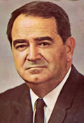 | 12. Asa Carter (Forrest Carter): Gillis Morgan, Auburn, Alabama: Asa Carter (1925-1979) is remembered as a promoter of white supremacist views, especially in his role as a speech writer for Alabama governor George C. Wallace; he is responsible for Wallace's infamous 1963 inaugural speech, which included the line "Segregation now! Segregation tomorrow! Segregation forever!" After an unsuccessful run for governor in 1970, he left the state and took on a new identity as Bedford Forrest Carter, authoring several Western adventure novels popularized by Hollywood, most notably as The Outlaw Josey Wales. He also wrote a nationally acclaimed work for young readers, The Education of Little Tree, which he claimed as autobiographical but was later exposed as a hoax.
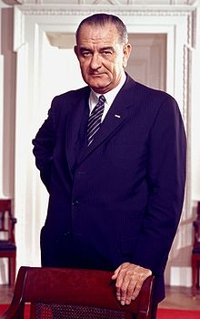 | 13. Lyndon B. Johnson  August 27, 1908 – January 22, 1973), often referred to as LBJ, was the 36th President of the United States (1963–1969), a position he assumed after his service as the 37th Vice President (1961–1963). Johnson, a Democrat from Texas, served as a United States Representative from 1937 to 1949 and as a United States Senator from 1949 to 1961, including six years as Senate Majority Leader, two as Senate Minority Leader and two as Senate Majority Whip. He campaigned unsuccessfully for the Democratic presidential nomination in 1960, but ran for Vice President with John F. Kennedy heading the ticket for the 1960 presidential election. After their election, Johnson succeeded Kennedy following his assassination on November 22, 1963; he completed Kennedy's term and was elected President in his own right in the 1964 election, winning by a large margin over Barry Goldwater. He is one of four people who have served in both offices of the executive branch as well as in both houses of Congress.
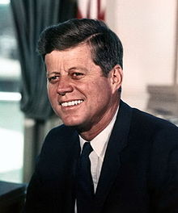 | 14. John F. Kennedy  (May 29, 1917 – November 22, 1963), commonly known as Jack Kennedy or by his initials JFK, was an American politician who served as the 35th President of the United States from January 1961 until his assassination in November 1963. Notable events that occurred during his presidency included the Bay of Pigs Invasion, the Cuban Missile Crisis, the Space Race—by initiating Project Apollo (which later culminated in the moon landings), the building of the Berlin Wall, the African-American Civil Rights Movement, and the increased US involvement in the Vietnam War.
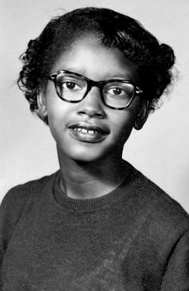 | 15. Claudette Colvin  (born September 5, 1939) is a pioneer of the African-American Civil Rights Movement. On March 2, 1955, she was the first person arrested for resisting bus segregation in Montgomery, Alabama, preceding the more publicized Rosa Parks incident by nine months.  Colvin was among the five plaintiffs originally included in the federal court case, filed on February 1, 1956 as Browder v. Gayle, and testified before the three-judge panel that heard the case in the United States District Court. On June 13, 1956, the judges determined that the state and local laws requiring bus segregation in Alabama were unconstitutional. The case went to the United States Supreme Court, which upheld their ruling on December 17, 1956. She was the last witness to testify and was considered the "star" witness. Three days later, the Supreme Court issued an order to Montgomery and the state to end bus segregation in Alabama.
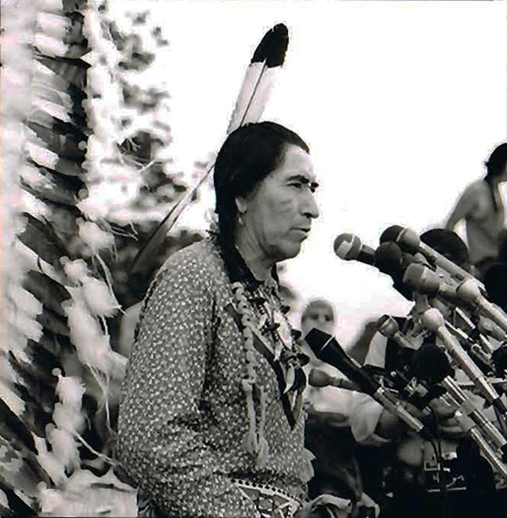 | 16. Phillip Deere  Phillip was a traditional healer from Nuyaka Grounds, Okemah, Oklahoma, who became a spiritual leader, civil and human rights activist, oral historian and storyteller. His children are: Mancie ‘Deere’ Dawson, Chumona “Hockte” Deere, Sam “Bonnie” Deere, Parnoskey Deere, Nova ‘Deere’ Wise, Lesah Deere-Yargee, Ahse Deere, Faulina Deere, and Manahwee Deere.  Phillip was a founder of the Traditional Youths and Elders Circle and a spiritual guide for the American Indian Movement (AIM). He was an elder and statesman for the International Indian Treaty Council (IITC), and participated in the United Nations International Human Rights Commission held in Geneva, Switzerland.  He spoke about remembering traditional values, Muscogee prophecies, care for Mother Earth, and brought attention to injustices suffered by indigenous peoples of the Americas.  He is a Creek Indian.
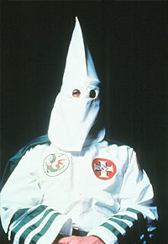 | 17. Klansman  Founded in 1866, the Ku Klux Klan (KKK) extended into almost every southern state by 1870 and became a vehicle for white southern resistance to the Republican Party’s Reconstruction-era policies aimed at establishing political and economic equality for blacks. Its members waged an underground campaign of intimidation and violence directed at white and black Republican leaders. Though Congress passed legislation designed to curb Klan terrorism, the organization saw its primary goal–the reestablishment of white supremacy–fulfilled through Democratic victories in state legislatures across the South in the 1870s. After a period of decline, white Protestant nativist groups revived the Klan in the early 20th century, burning crosses and staging rallies, parades and marches denouncing immigrants, Catholics, Jews, blacks and organized labor. The civil rights movement of the 1960s also saw a surge of Ku Klux Klan activity, including bombings of black schools and churches and violence against black and white activists in the South.
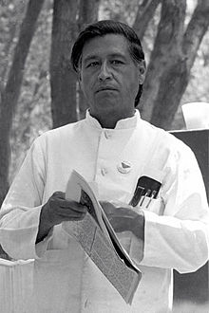 | 18. Cesar Chavez  March 31, 1927 – April 23, 1993) was an American farm worker, labor leader and civil rights activist, who, with Dolores Huerta, co-founded the National Farm Workers Association (later the United Farm Workers union, UFW).^{[1]}  A Mexican American, Chavez became the best known Latino American civil rights activist, and was strongly promoted by the American labor movement, which was eager to enroll Hispanic members. His public-relations approach to unionism and aggressive but nonviolent tactics made the farm workers' struggle a moral cause with nationwide support. By the late 1970s, his tactics had forced growers to recognize the UFW as the bargaining agent for 50,000 field workers in California and Florida. However, by the mid-1980s membership in the UFW had dwindled to around 15,000.^{[2]}
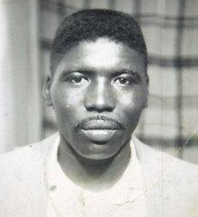 | 19. Jimmie Lee Jackson  (December 16, 1938 – February 26, 1965)^{[1][2]} was a civil rights activist in Marion, Alabama, and a deacon in the Baptist church. On February 18, 1965, while participating in a peaceful voting rights march in his city, he was beaten by troopers and shot by Alabama State Trooper James Bonard Fowler.^{[3]} Jackson was unarmed and died eight days later in the hospital.  His death was part of the inspiration for the Selma to Montgomery marches in March 1965, a major event in the American Civil Rights Movement that helped gain Congressional passage of the Voting Rights Act of 1965. This opened the door to millions of African Americans being able to vote again in Alabama and across the South, regaining participation as citizens in the political system for the first time since the turn of the 20th century, when they were disenfranchised by state constitutions and discriminatory practices.^{[3]}
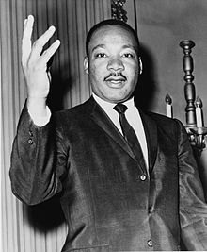 | 20. Dr. Martin Luther King, Jr.  (January 15, 1929 – April 4, 1968) was an American Baptist minister, activist, humanitarian, and leader in the African-American Civil Rights Movement. He is best known for his role in the advancement of civil rights using nonviolent civil disobedience based on his Christian beliefs.  King became a civil rights activist early in his career. He led the 1955 Montgomery Bus Boycott and helped found the Southern Christian Leadership Conference (SCLC) in 1957, serving as its first president. With the SCLC, King led an unsuccessful 1962 struggle against segregation in Albany, Georgia (the Albany Movement), and helped organize the 1963 nonviolent protests in Birmingham, Alabama, that attracted national attention following television news coverage of the brutal police response. King also helped to organize the 1963 March on Washington, where he delivered his famous "I Have a Dream" speech. There, he established his reputation as one of the greatest orators in American history.
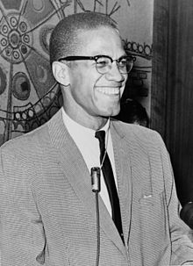 | 21. Malcolm X  May 19, 1925 – February 21, 1965), born Malcolm Little and also known as El-Hajj Malik El-Shabazz^{[A]} (Arabic: الحاجّ مالك الشباز‎), was an American Muslim minister and a human rights activist. To his admirers he was a courageous advocate for the rights of blacks, a man who indicted white America in the harshest terms for its crimes against black Americans; detractors accused him of preaching racism and violence. He has been called one of the greatest and most influential African Americans in history. Malcolm X was effectively orphaned early in life. His father was killed when he was six and his mother was placed in a mental hospital when he was thirteen, after which he lived in a series of foster homes. In 1946, at age 20, he went to prison for larceny and breaking and entering. While in prison, Malcolm X became a member of the Nation of Islam, and after his parole in 1952, quickly rose to become one of the organization's most influential leaders, serving as the public face of the controversial group for a dozen years. During this time, in keeping with the Nation's teachings, he promoted black supremacy, advocated the separation of black and white Americans, and rejected the civil rights movement's emphasis on integration. In his autobiography, Malcolm wrote proudly of some of the social achievements the Nation made while he was a member.
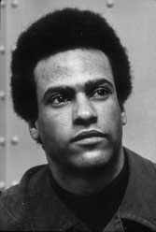 | 22. Huey Newton  (February 17, 1942 – August 22, 1989) was an African-American political activist who, along with Bobby Seale, co-founded the Black Panther Party in 1966. Newton had a long series of confrontations with law enforcement, including several convictions, while he participated in political activism. He continued to pursue an education, eventually earning a Ph.D. in Social Science.^{[1][2]} Newton spent time in prison for manslaughter due to his alleged involvement in a shooting that killed a police officer, but was later acquitted. In 1989 he was shot and killed in Oakland, California, by Tyrone "Double R" Robinson, a member of the Black Guerrilla Family
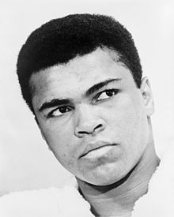 | 23. Muhammad Ali  January 17, 1942) is an American former professional boxer, generally considered among the greatest heavyweights in the sport's history. A controversial and polarizing figure during his early career, Ali is today widely regarded for the skills he displayed in the ring plus the values he exemplified outside of it: religious freedom, racial justice and the triumph of principle over expedience.^{[3][4]} He is one of the most recognized sports figures of the past 100 years, crowned "Sportsman of the Century" by Sports Illustrated and "Sports Personality of the Century" by the BBC.^{[5][6]}  Born Cassius Clay, he began training at 12 years old and at the age of 22 won the world heavyweight championship in 1964 from Sonny Liston in a stunning upset. Shortly after that bout, Ali joined the Nation of Islam and changed his name. He converted to Islam in 1975.
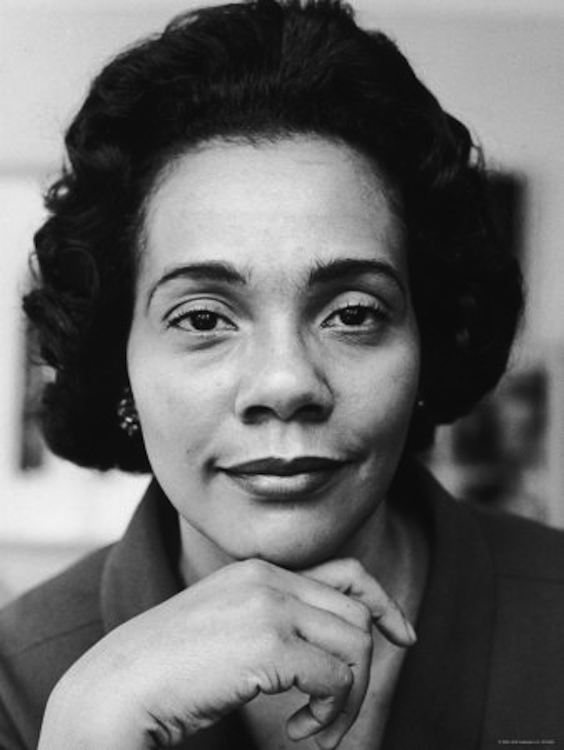 | 24. Coretta Scott King  April 27, 1927 – January 30, 2006) was an American author, activist, and civil rights leader. Coretta Scott King helped lead the African-American Civil Rights Movement in the 1960s. King was an active advocate for African-American equality. King met Martin Luther King, Jr. while in college and their participation escalated until they became central to the movement. In her early life Coretta was an accomplished singer and often incorporated music into her civil rights work.  King played a prominent role in the years after her husband's 1968 assassination when she took on the leadership of the struggle for racial equality herself and became active in the Women's Movement and the LGBT rights movement. King founded the King Center and sought to make his birthday a national holiday. King finally succeeded when Ronald Reagan signed legislation which established Martin Luther King, Jr. Day. She later broadened her scope to include both opposition to apartheid and advocacy for LGBT rights. King became friends with many politicians before and after her Martin Luther King's death, most notably John F. Kennedy, Lyndon B. Johnson, and Robert F. Kennedy. John F. Kennedy's phone call to her during the 1960 election was what she liked to believe was behind his victory.
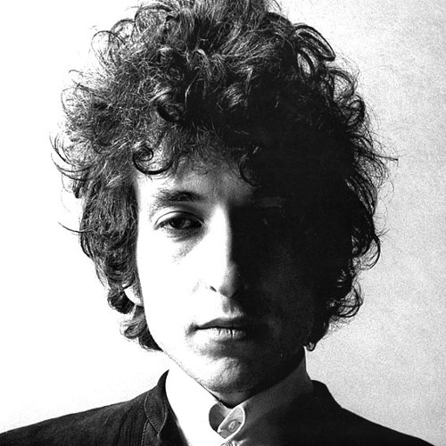 | 25. Bob Dylan  May 24, 1941) is an American singer-songwriter, artist and writer. He has been influential in popular music and culture for more than five decades. Much of his most celebrated work dates from the 1960s when his songs chronicled social unrest, although Dylan repudiated suggestions from journalists that he was a spokesman for his generation. Nevertheless, early songs such as "Blowin' in the Wind" and "The Times They Are a-Changin'" became anthems for the American civil rights and anti-war movements. Leaving his initial base in the American folk music revival, Dylan's six-minute single "Like a Rolling Stone" altered the range of popular music in 1965. His mid-1960s recordings, backed by rock musicians, reached the top end of the United States music charts while also attracting denunciation and criticism from others in the folk movement.  Dylan's lyrics have incorporated a variety of political, social, philosophical and literary influences. They defied existing pop music conventions and appealed to the burgeoning counterculture. Initially inspired by the performances of Little Richard, and the songwriting of Woody Guthrie, Robert Johnson and Hank Williams, Dylan has amplified and personalized musical genres. His recording career, spanning 50 years, has explored the traditions in American song—from folk, blues, and country to gospel, rock and roll, and rockabilly to English, Scottish, and Irish folk music, embracing even jazz and the Great American Songbook. Dylan performs with guitar, keyboards and harmonica. Backed by a changing line-up of musicians, he has toured steadily since the late 1980s on what has been dubbed the Never Ending Tour. His accomplishments as a recording artist and performer have been central to his career, but his greatest contribution is considered his songwriting.
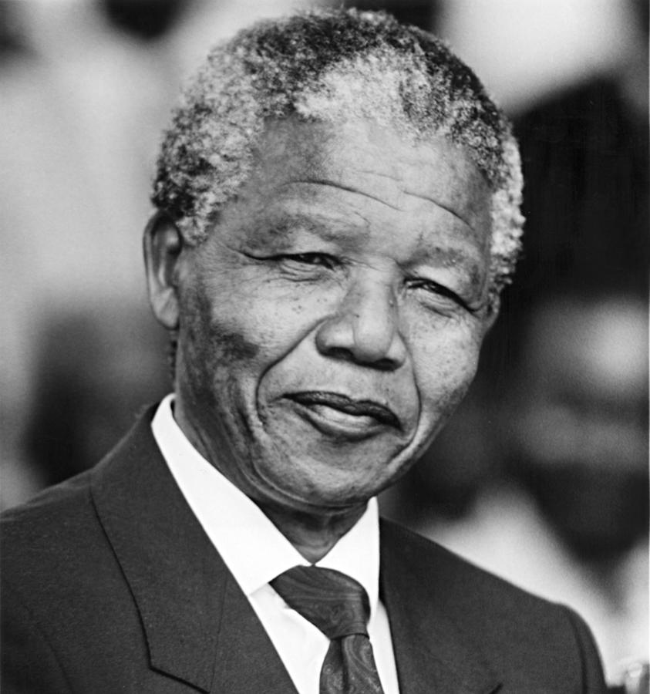 | 26. Nelson Mandela  18 July 1918 – 5 December 2013) was a South African anti-apartheid revolutionary, politician and philanthropist who served as President of South Africa from 1994 to 1999. He was South Africa's first black chief executive, and the first elected in a fully representative democratic election. His government focused on dismantling the legacy of apartheid through tackling institutionalised racism, poverty and inequality, and fostering racial reconciliation. Politically an African nationalist and democratic socialist, he served as President of the African National Congress (ANC) party from 1991 to 1997. Internationally, Mandela was Secretary General of the Non-Aligned Movement from 1998 to 1999.  A Xhosa born to the Thembu royal family, Mandela attended Fort Hare University and the University of Witwatersrand, where he studied law. Living in Johannesburg, he became involved in anti-colonial politics, joining the ANC and becoming a founding member of its Youth League. After the Afrikaner minority government of the National Party established apartheid in 1948, he rose to prominence in the ANC's 1952 Defiance Campaign, was appointed superintendent of the organisation's Transvaal chapter and presided over the 1955 Congress of the People. Working as a lawyer, he was repeatedly arrested for seditious activities and, with the ANC leadership, was unsuccessfully prosecuted in the Treason Trial from 1956 to 1961. Influenced by Marxism, he secretly joined the South African Communist Party (SACP) and sat on its Central Committee. Although initially committed to non-violent protest, in association with the SACP he co-founded the militant Umkhonto we Sizwe (MK) in 1961, leading a sabotage campaign against the apartheid government. In 1962, he was arrested, convicted of conspiracy to overthrow the state, and sentenced to life imprisonment in the Rivonia Trial.
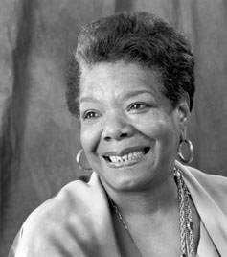 | 27. Maya Angelou  April 4, 1928 – May 28, 2014) was an American author, poet, dancer, actress, and singer. She published seven autobiographies, three books of essays, and several books of poetry, and was credited with a list of plays, movies, and television shows spanning over 50 years. She received dozens of awards and more than 50 honorary degrees.^{[3]} Angelou is best known for her series of seven autobiographies, which focus on her childhood and early adult experiences. The first, I Know Why the Caged Bird Sings (1969), tells of her life up to the age of 17 and brought her international recognition and acclaim.  She became a poet and writer after a series of occupations as a young adult, including fry cook, prostitute, nightclub dancer and performer, cast member of the opera Porgy and Bess, coordinator for the Southern Christian Leadership Conference, and journalist in Egypt and Ghana during the decolonization of Africa. She was an actor, writer, director, and producer of plays, movies, and public television programs. In 1982, she earned the first lifetime Reynolds Professorship of American Studies at Wake Forest University in Winston-Salem, North Carolina. She was active in the Civil Rights movement, and worked with Martin Luther King, Jr. and Malcolm X. Beginning in the 1990s, she made around 80 appearances a year on the lecture circuit, something she continued into her eighties. In 1993, Angelou recited her poem "On the Pulse of Morning" (1993) at President Bill Clinton's inauguration, making her the first poet to make an inaugural recitation since Robert Frost at President John F. Kennedy's inauguration in 1961.
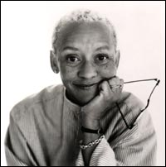 | 28. Nikki Giovanni  (born June 7, 1943) is an American writer, commentator, activist, and educator. One of the world's most well-known African American poets,^{[2]} her work includes poetry anthologies, poetry recordings, and nonfiction essays, and covers topics ranging from race and social issues to children's literature. She has won numerous awards, including the Langston Hughes Medal, the NAACP Image Award, and has been nominated for a Grammy Award,for her Nikki Giovanni Poetry Collection. Additionally, she has recently been named as one of Oprah Winfrey’s twenty- five “Living Legends.” (29) ^{[2]}  Giovanni gained initial fame in the late 1960s as one of the foremost authors of the Black Arts Movement. Influenced by the civil rights and Black Power movements of the period, her early work provides a strong, militant African- American perspective, leading one writer to dub her the "Poet of the Black Revolution."^{[2]} During the 1970s, she began writing children's literature, and co-founded a publishing company, NikTom,Ltd to provide an outlet for other African American women writers. Over subsequent decades, her works discussed social issues, human relationships, and hip-hop. Poems such as "Knoxville, Tennessee," and "Nikki-Rosa" have been frequently re-published in anthologies and other collections.
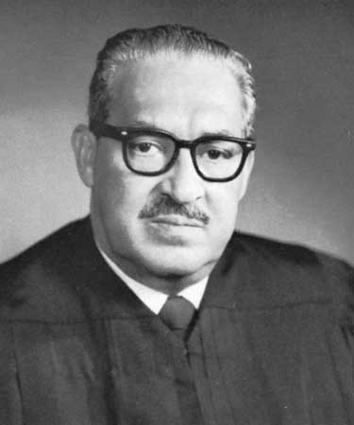 | 29. Thurgood Marshall  (July 2, 1908 – January 24, 1993) was an Associate Justice of the United States Supreme Court, serving from October 1967 until October 1991. Marshall was the Court's 96th justice and its first African-American justice.  Before becoming a judge, Marshall was a lawyer who was best known for his high success rate in arguing before the Supreme Court and for the victory in Brown v. Board of Education, a decision that desegregated public schools. He served on the United States Court of Appeals for the Second Circuit after being appointed by President John F. Kennedy and then served as the Solicitor General after being appointed by President Lyndon Johnson in 1965. President Johnson nominated him to the United States Supreme Court in 1967.

