Name
Selma Gallery Walk
Station 1.
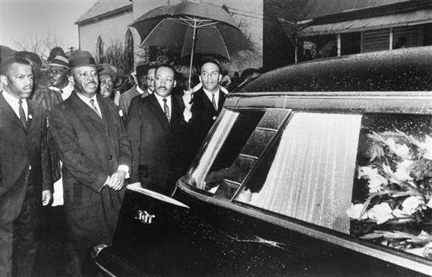
February 18,1965
Jimmie Lee Jackson was shot twice in the abdomen by a state trooper after participating in a night march organized by the SCLC. The marchers had planned to walk from the church to the jail, about half a block, to protest the jailing of civil rights leader James Orange, who had been jailed for enlisting young people to help in black voter registration campaigns. Jackson died on February 25, 1965. In this image, Dr. King follows his funeral procession.

Based on the photograph, which appeal is most present? Explain your answer.

With that appeal in mind, what message is this image sending about the Selma marches?

Station 2.
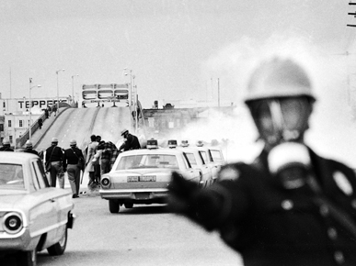
March 7, 1965
To protest the death of Jimmie Lee Jackson, about 600 protesters began marching across the Edmund Pettus Bridge in Selma with Dr. King. Police responded by releasing tear gas on the marchers, beating them with clubs, and charging them on horseback. Seventeen marchers were hospitalized. The day was called “Bloody Sunday.”

Write a short journal entry from the perspective of the photographer in front of this officer.

Station 3.
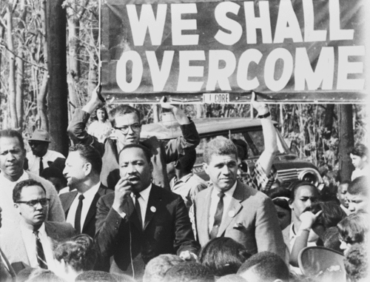
March 9, 1965
“Turn around Tuesday” Responding to the attack on Sunday’s marchers, Dr. King leads 1,500 marchers and clergy to face state troopers, kneel, pray, sing ‘We Shall Overcome”, and return to the Selma/Brown
Chapel to avoid further violence against the protesters.

For this station, create your own chant, slogan, or phrase that you would use if you were a part of the Selma marches. Use pathos.
Station 4.
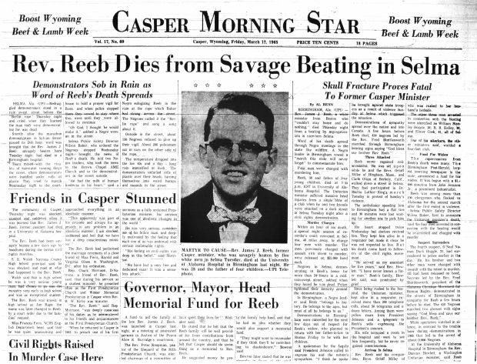
March 9, 1965
Jim Reeb and two others are attacked that night after leaving restaurant in Selma. Reeb had traveled to Selma to answer Martin Luther King’s call for clergy to support the nonviolent protest movement for voting rights there.

Based on the photograph, which appeal is most present? Explain your answer.

Based on the headline, what conclusion can be made about his death in Selma?

With that in mind, what message is this article sending about the Selma marches?

Station 5.
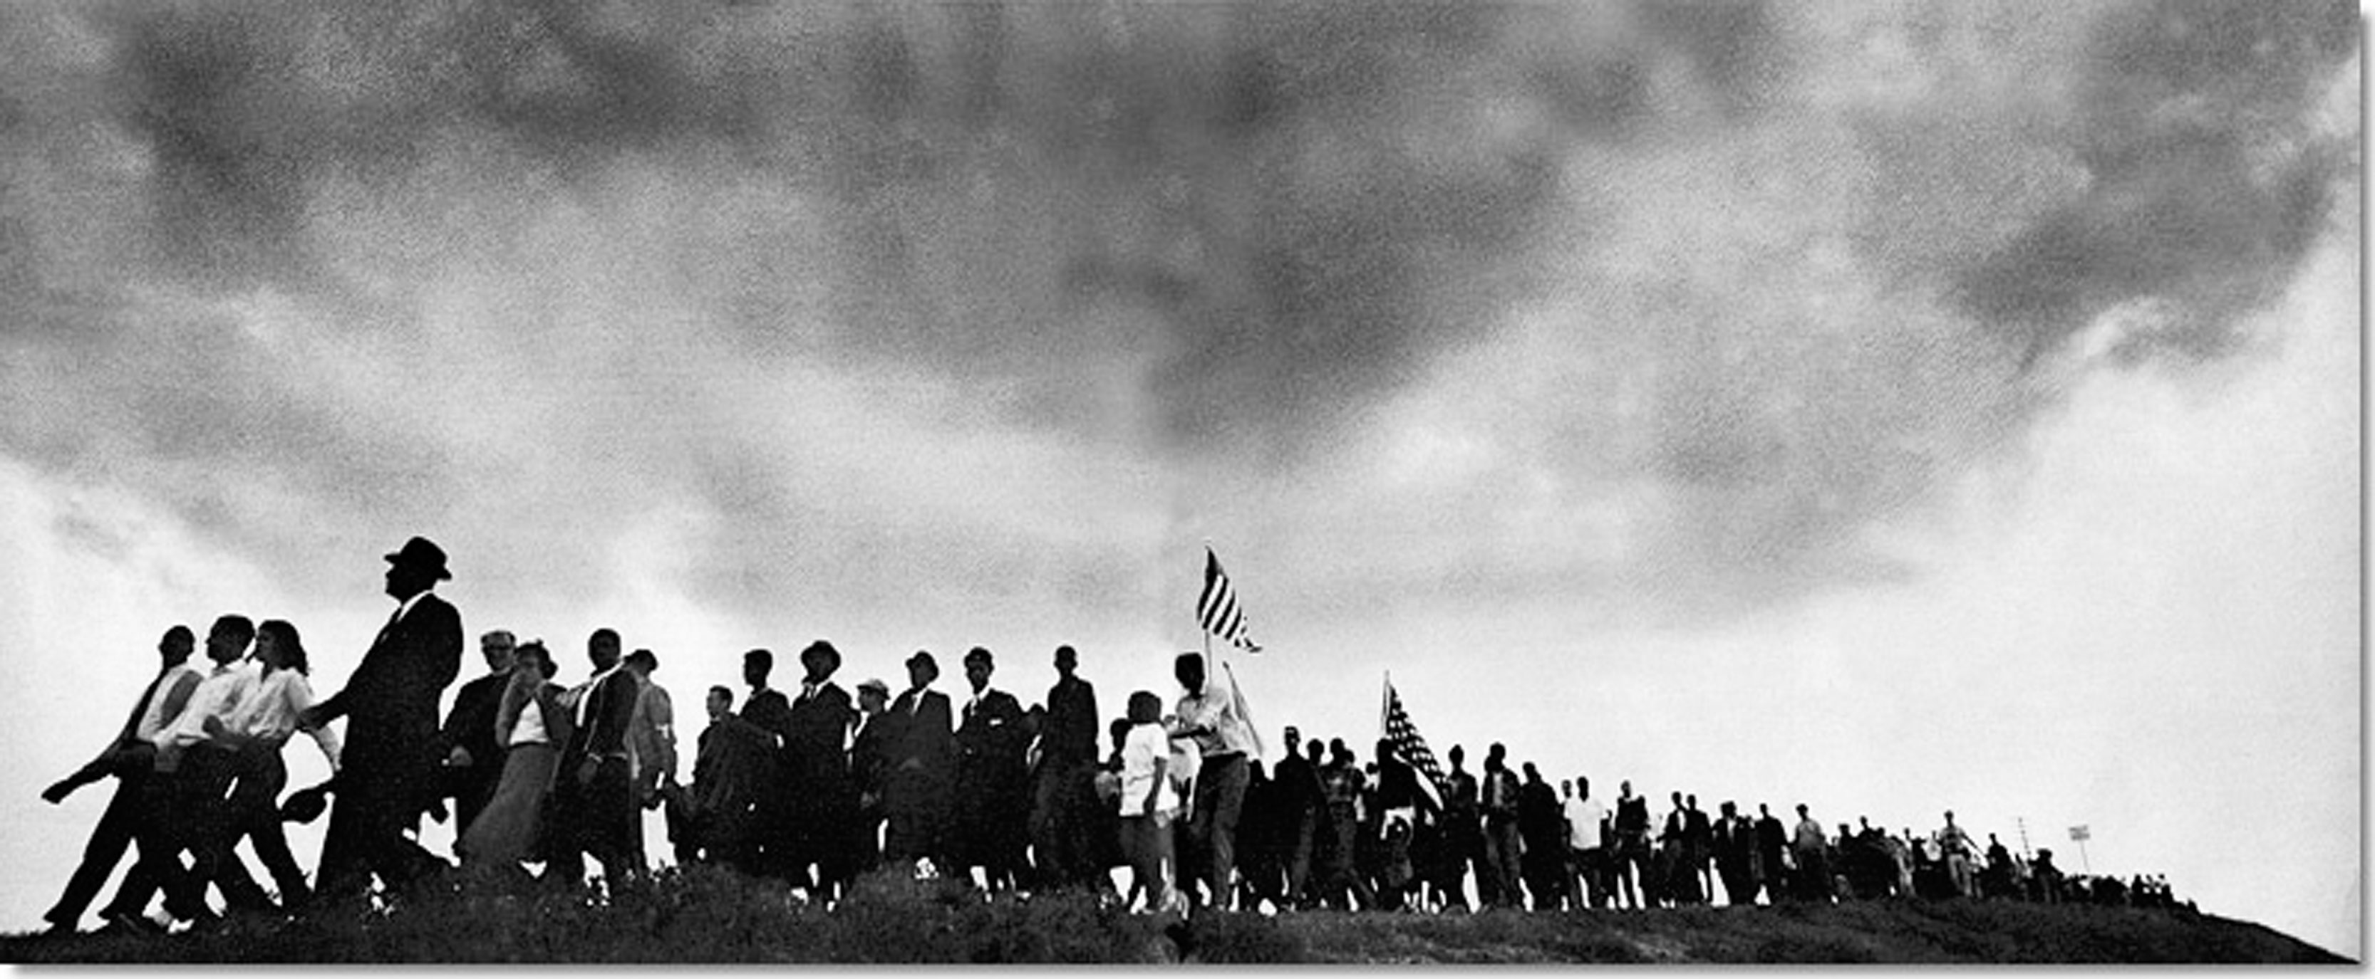
March 21-25, 1965
Dr. King led over 25,000 marchers along Route 80 from Selma to Montgomery to advocate for the rights of black Americans to vote. They camped out each night at a different location and thousands joined along the way. Marchers were protected by the National Guard along the entire route.

How does this image compare to protests we’ve seen in the 21st century?

How is it different? (Think of ways we share information today)

Station 6.
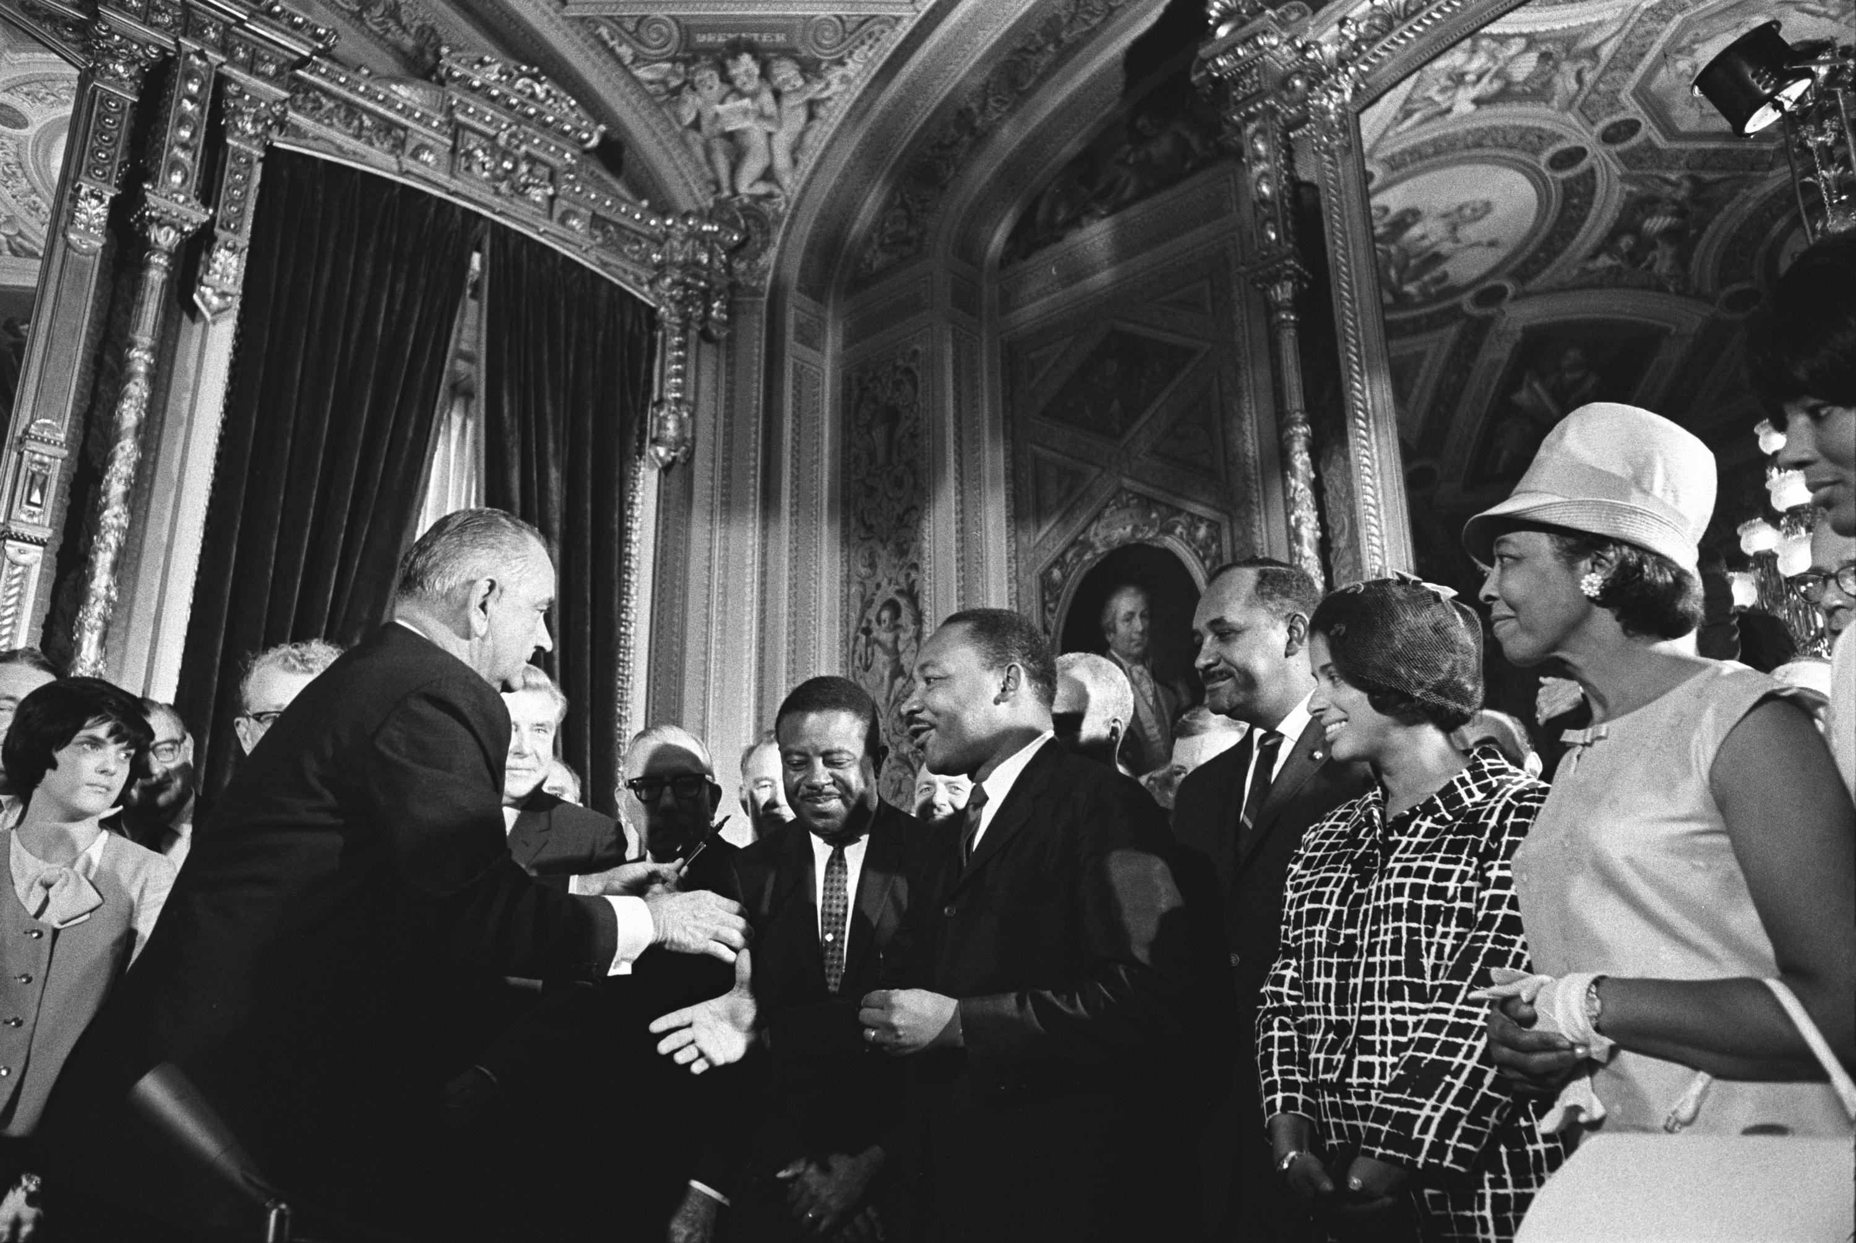
August 6, 1965
The Voting Rights Act of 1965 was signed into law by Presiden Lydon B. Johnson. It prohibits racial discrimination in voting.

Create three different captions for this image using each rhetorical appeal.

Pathos: ________________________________________________________________

Logos: _________________________________________________________________

Ethos: _________________________________________________________________

