Fences Reading Guide
Use this sheet to help you organize information about characters. As you read, add key lines spoken by each character (include the page number)

Setting
Time | Place
Characters

Mr. Lubin
Father
Mother
Miss Pearl
Joe Canewell’s daughter

+ 9 siblings

Gabriel

Troy Maxson

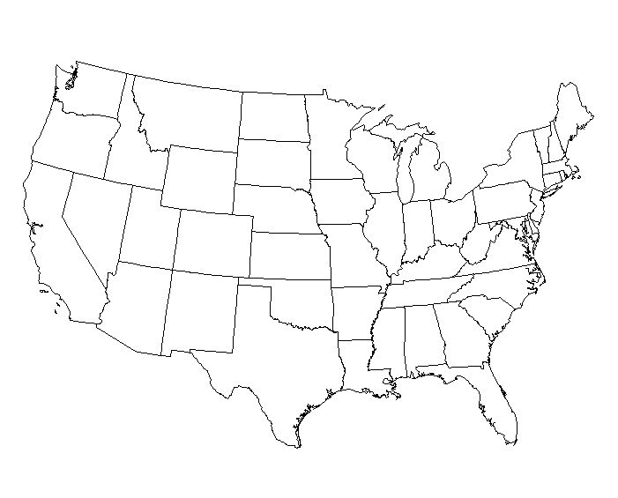

Rose (née Lee)

Lennie Small

Wife 1

Lyons

Cory

Pennsylvania


Bonnie

Draw lines showing the connections between characters.

Love
Respect
Power
Dependence
__________________
__________________
__________________

Brownie

Mr. Stawicki
Mr. Rand

Jim Bono

Jesse

Bella

Earl

Coach Zellman
Lucille

