The “One Pager”

After reading the first chapter of To Kill a Mockingbird, create the following on a sheet of white paper. Make it visually interesting and fill up the whole page. If you have read more than chapter 1, you can draw from any of the pages you have read. If you are reading Other Voices, Other Rooms, you may do this assignment on that novel instead. This assignment is due at the end of class.

1. the title of the novel and the author’s name
Remember that titles of novels are underlined when handwritten.
Remember to capitalize the name of the novel and the author’s name correctly.

2. one or more significant sentences related to your motif
Write one or more sentences from the chapter(s) that you think reveal the most about your motif. Put quotation marks around these sentences. Include the page number in parentheses after the quotation marks.

3. a theme statement
Remember that a theme statement is a complete sentence that states the lesson or message that the chapter sends. It is a general statement that is true in the novel and true in life for most people. This sentence does not mention specific characters or plot events, and it should not be cliché (such as “Don’t judge a book by its cover”). Your theme statement must include one word from your motif group title.

4. a visual element about symbol
Draw a symbol from the story related to your motif. Explain what the symbol represents in words.

5. one body paragraph in which you discuss an observation about character related to your motif.
You can write it on the front or the back of your paper. Your paragraph should include a topic sentence with an opinion or assertion to “prove,” about how your chosen character relates to your motif, one pieces of support from the story to support your assertion, elaboration that explains how your support sentence back up your assertion, and a conclusion sentence that discusses the significance of the point you have “proven.” Write in complete sentences.

Checklist

- _____ novel title underlined and author name
- _____ 2 sentences related to motif
- _____ theme statement related to motif
- _____ symbol with explanation of what it represents
- _____ paragraph where you prove your opinion about a character

Format of a Body Paragraph (follows ACE-IT). Fill in the blank for your paragraph rough draft and then copy the full paragraph neatly onto the front or back of your one-pager:

1. Assertion (Topic Sentence):

In _______________________________, the character _______________________ shows

____________________________________________________________________________________________.
(connection to motif).

2. Context (introduce evidence):

For example, consider when_____________________________________________________________________

___________________________________________________________________________________________.
(describe what is happening in the chapter part of the chapter your evidence comes from)

3. Evidence

Lee writes/Scout says/Jem says/Dill says/Atticus says/_____________________ (circle one or fill in the blank),

“____________________________________________________________________________________________

_______________________________________________________________________” (_____). page number
(provide a phrase from the text that proves your point about this character’s connection to the motif)

4. Interpretation of evidence (explain how the phrase or sentence you chose from the text proves your assertion)

_____________________________________________________________________________________________

_____________________________________________________________________________________________

_____________________________________________________________________________________________

5. Take it to the next level / Transition (Because this is a freestanding paragraph and not part of a larger essay, you will not write a Transition. Instead, you will Take it to the next level. Explain why your point about this character matters in the broader scheme of the novel)

It is important to understand that _________________________________________________________________ (sum up your point about the character)

because_______________________________________________________________________________________

_____________________________________________________________________________________________.
(how does this point connect to other characters or the story as a whole? if we didn’t know this about the character how would we be misled? why would the story not make sense without this idea about the character?)

Example One-Pager on a short story “How to Talk to Girls at Parties” by Neil Gaiman:

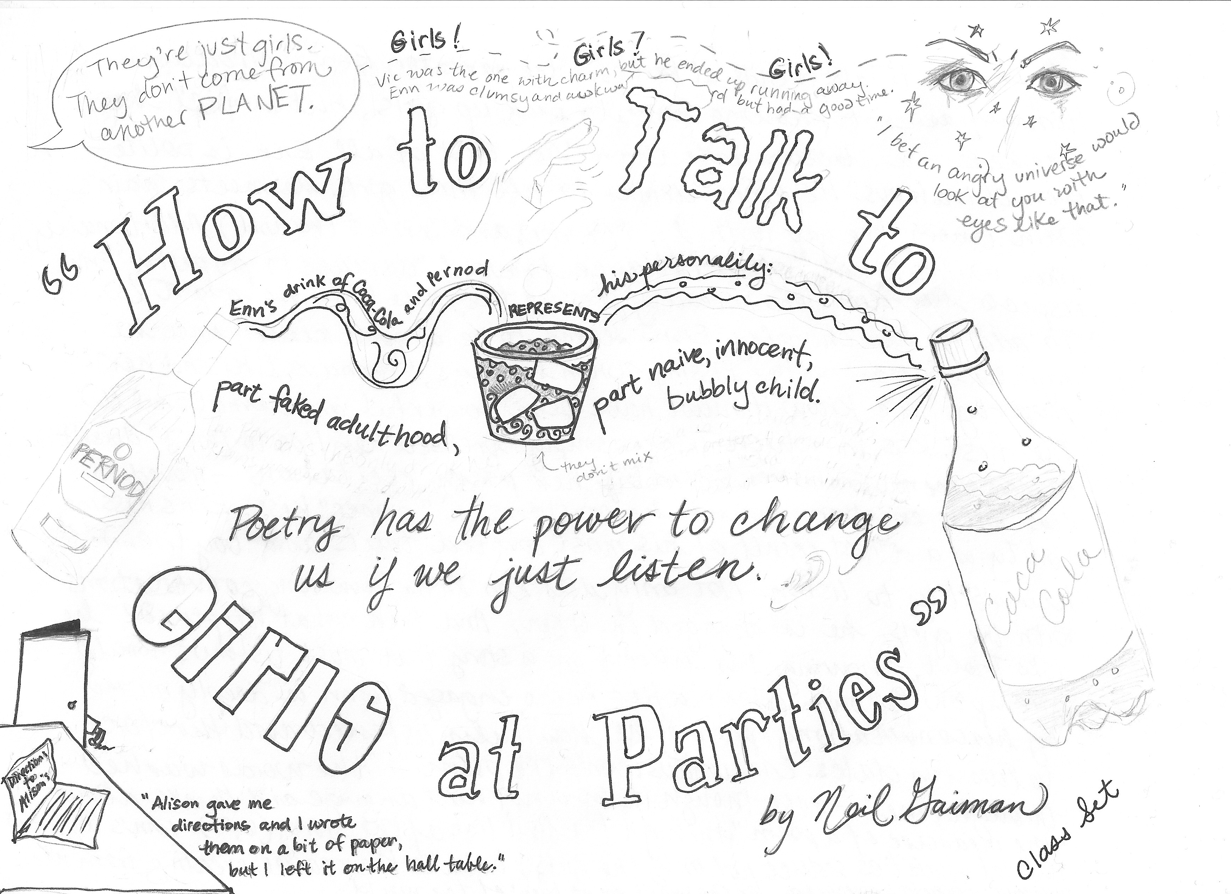

Example Paragraph on back about appearance and reality:

The narrator of “How to Talk to Girls at Parties” introduces himself as not knowing how to pick up girls, but in fact he makes a better date than Vic [Assertion proving an opinion or observation--not a fact. The motif here is appearances and reality]. For example, consider when Enn is talking with one of the girls toward the end of the story, Enn is deeply moved by the conversation, proving he has truly listened and therefore values his dates, despite the fact that he appears nervous. [Context for Evidence] The narrator, Enn, writes that the girl’s “words washed through me” — and thinks about what she has said all the way through the last line of the story (6). [Evidence] The phrase “washed through me” implies that not only has Enn listened, unlike his more macho friend Vic, but he has immersed himself in the words of his date. [Interpretation of evidence] Enn’s boyfriend-material qualities seduce not only the girls, but also the reader, creating in his audience a greater appreciation for the smart, quiet boys of the world–not the Vics. [Conclusion stating the significance of your argument]

